itransport 2 Mockup Demo Application

# Required software

1. UI design Software
   1. Tomcat Server
   2. Apache Maven
   3. Boostrap 4.3
   4. AngularJS
   5. JDK 1.8 / JRE 1.8
2. GIS
   1. Openmaptile Server
      1. Docker Quickstart Terminal
      2. Kitematic
      3. VM Virtual Box Manager

**Note :** Docker comes with Kitematic & VM virtual Box

* 1. Geoserver
     1. GeoServer
     2. Postgre SQL
     3. GIS DB – “postgis-bundle-pg94x64-setup-2.5.1-1.exe”
  2. ArcGIS API for JavaScript 3.28

1. BIS

**To launch Mockup Demo**

To start the following servers before launch the application.

1. Tomcat
2. Docker
3. Kitematic
4. GeoServer
5. Copy **arcgis api java scriptfolder** to server folder where you deploy (tomcat /webapp/youfolder/ and paste **arcgis api java scriptfolder**

# Dockers installation

DockerToolbox.exe – Run as administrator mode

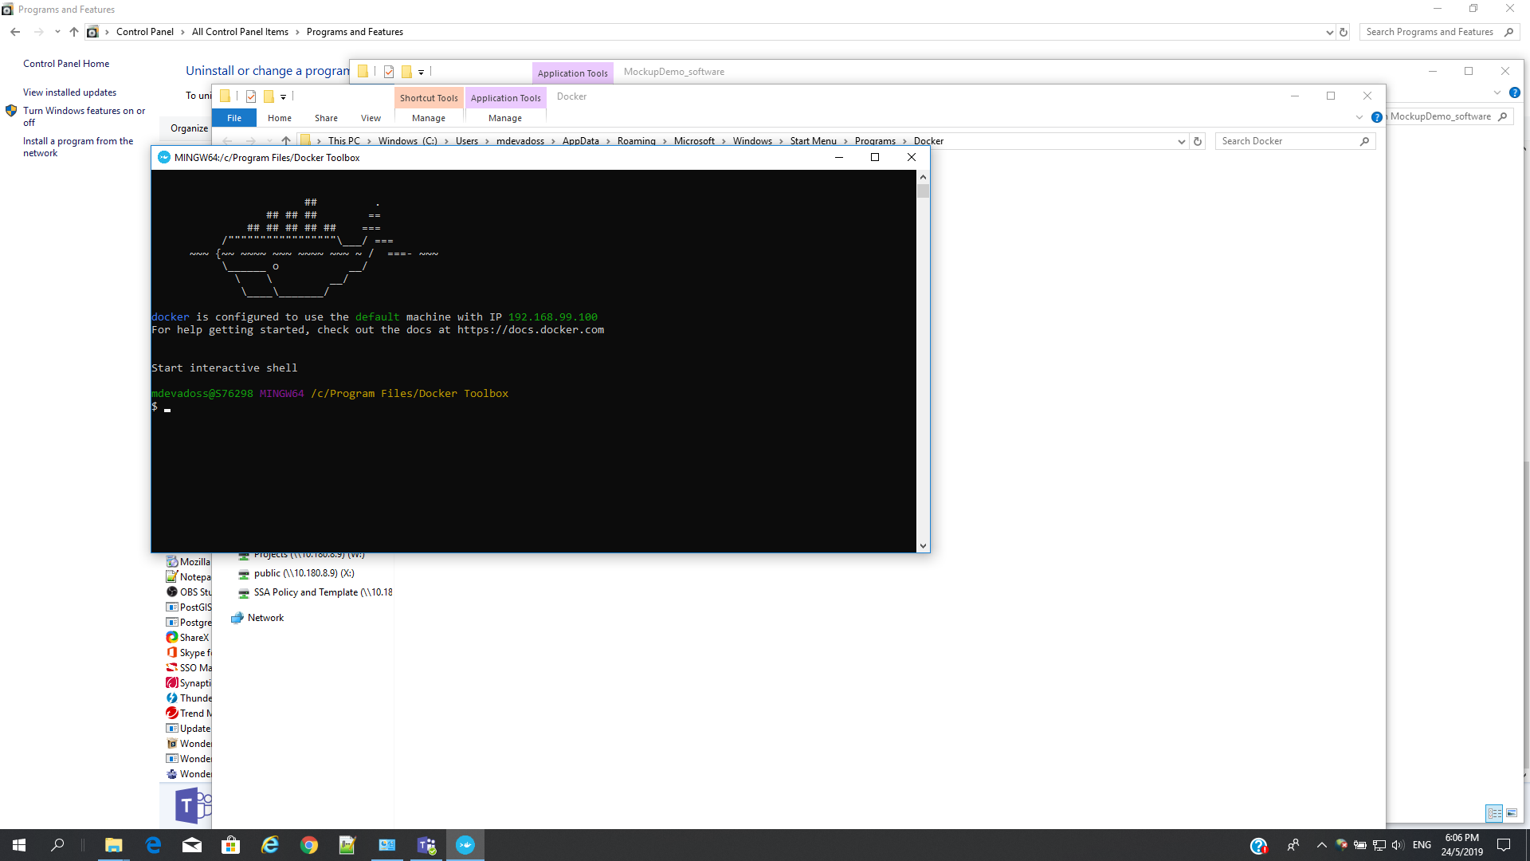

2. Kitematics from Start menu - Run as administrator mode

a. Look for openmaptile Server – create

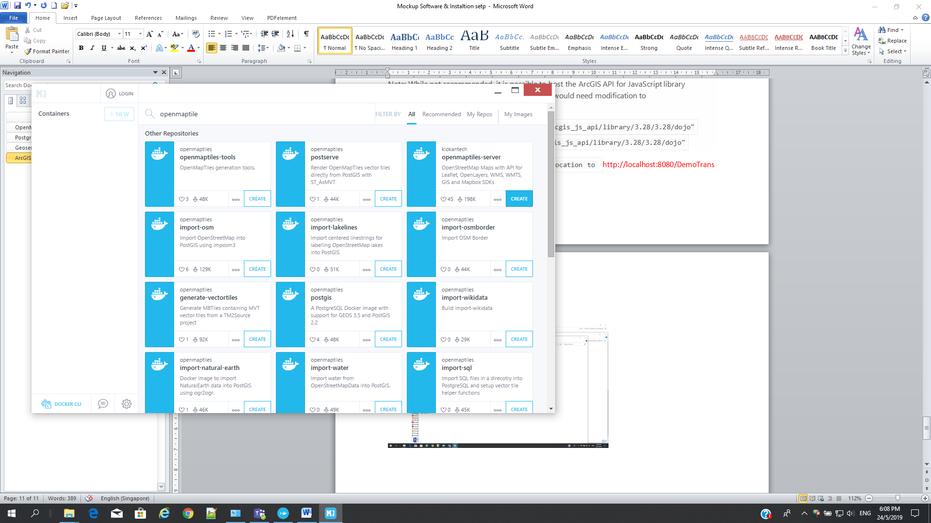

1. To launch in browser by click pointed image

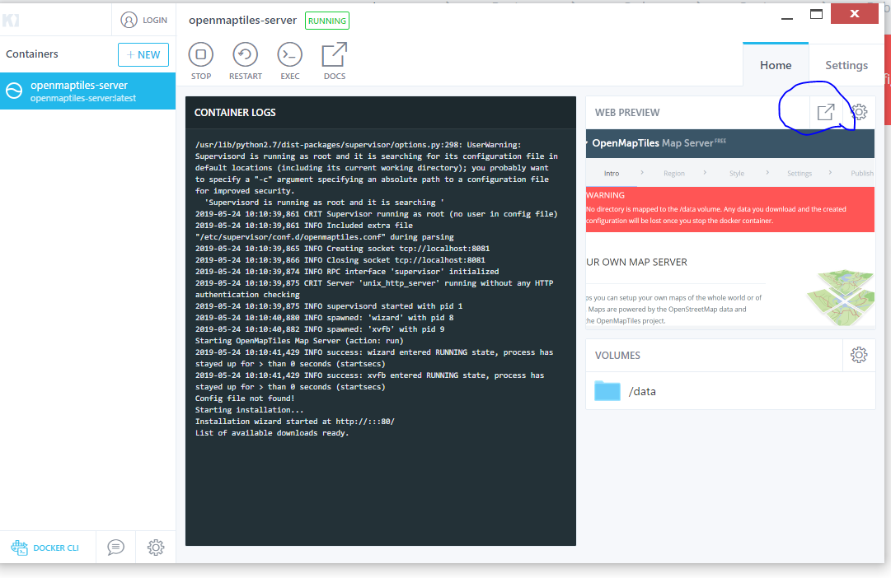

# OpenMapTile Server – setup and region selection

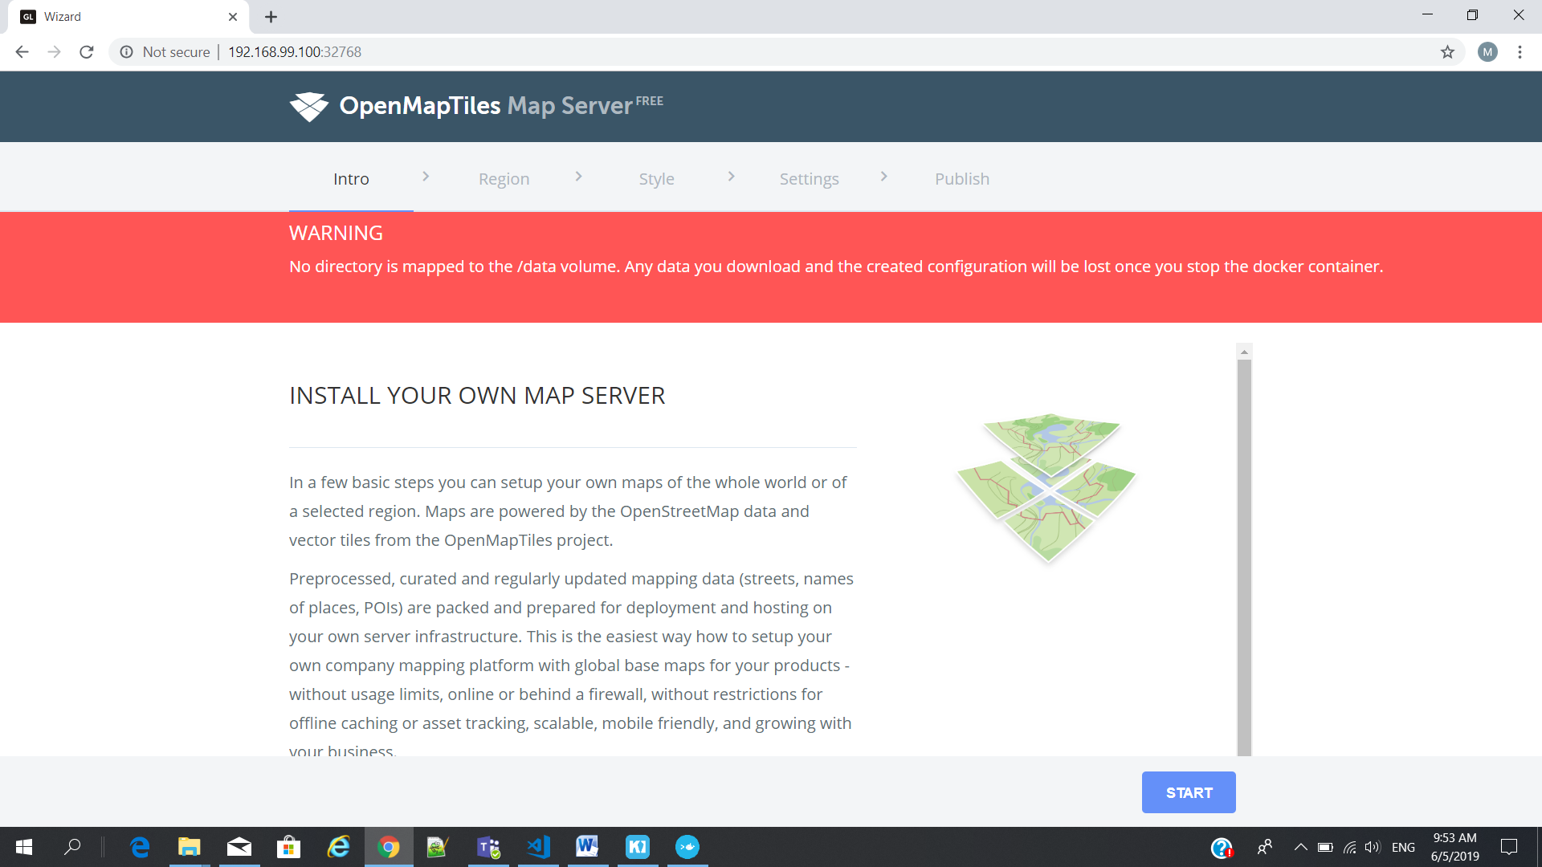

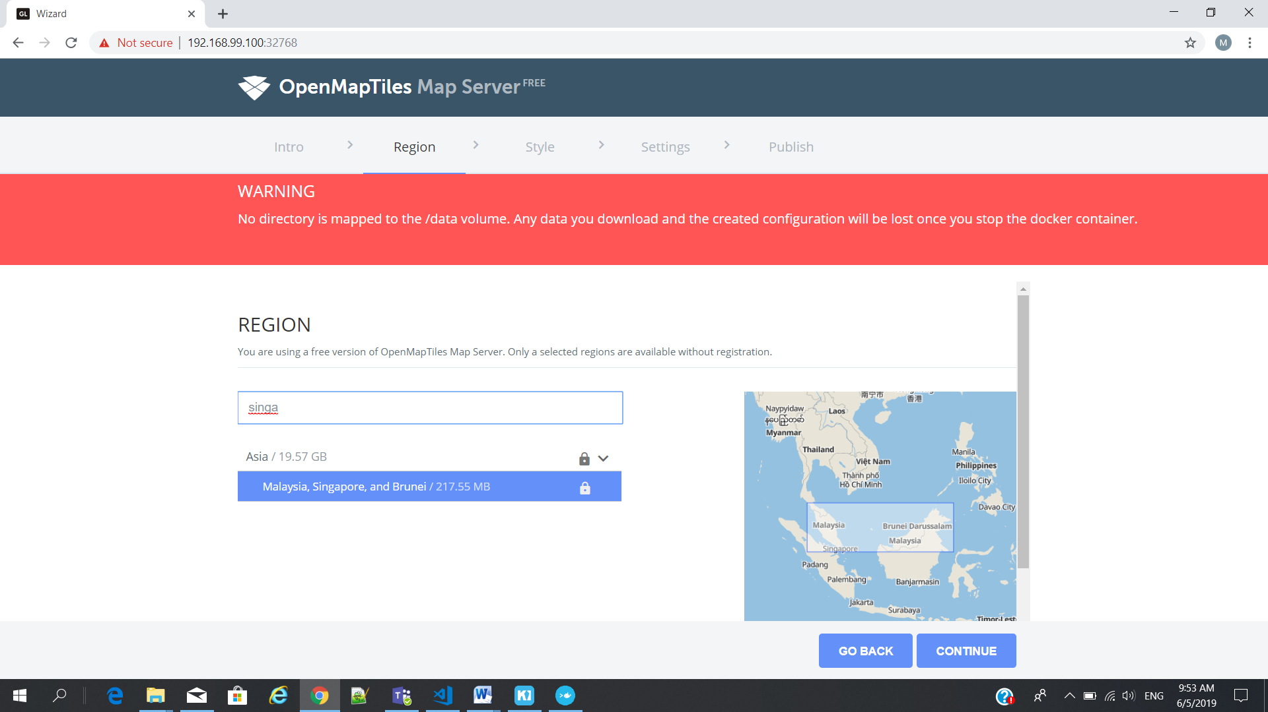

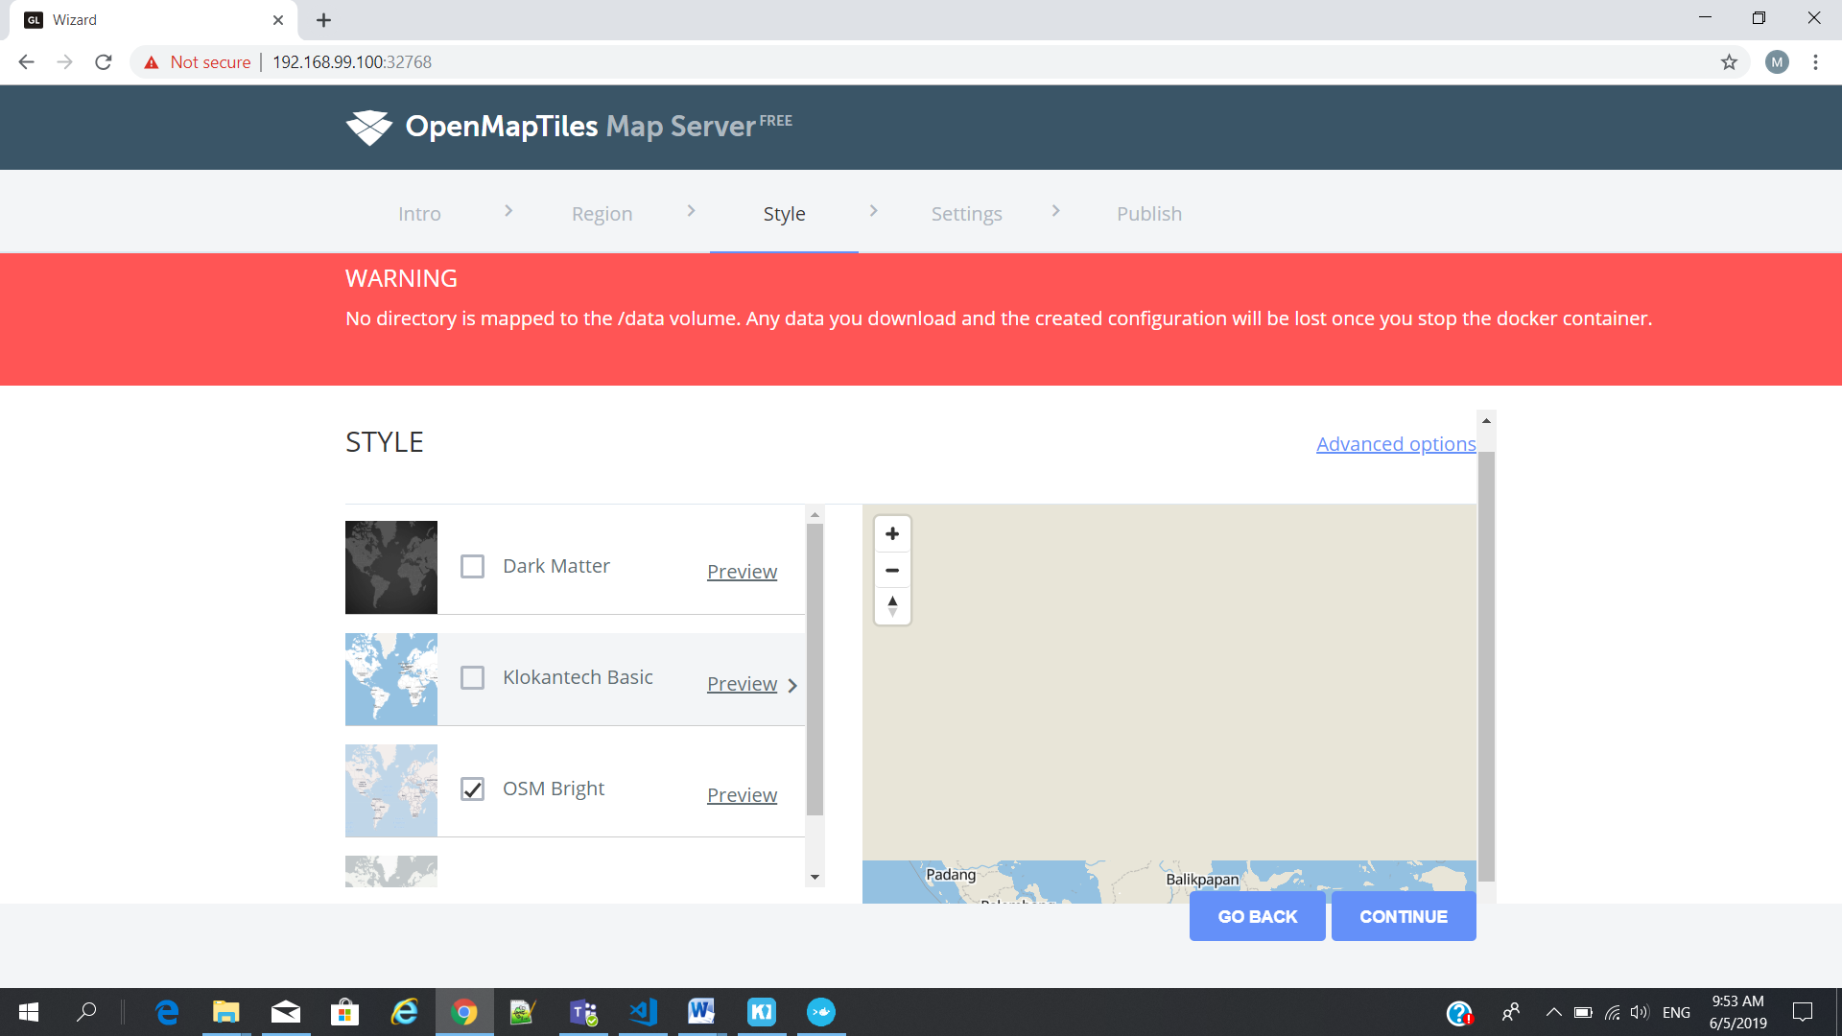

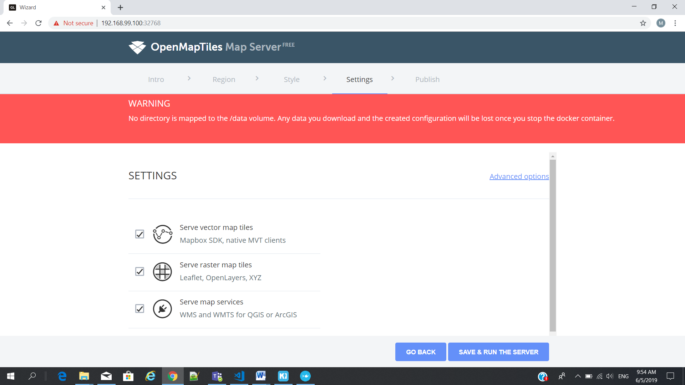

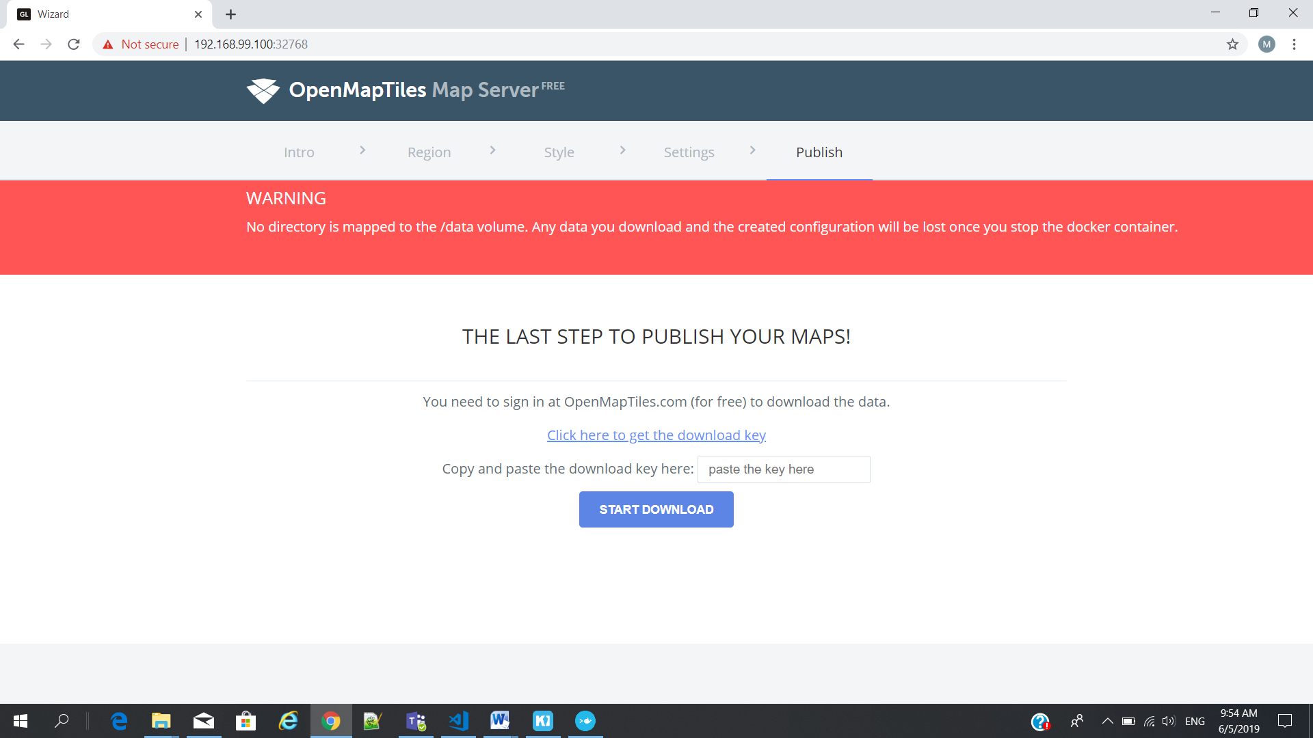

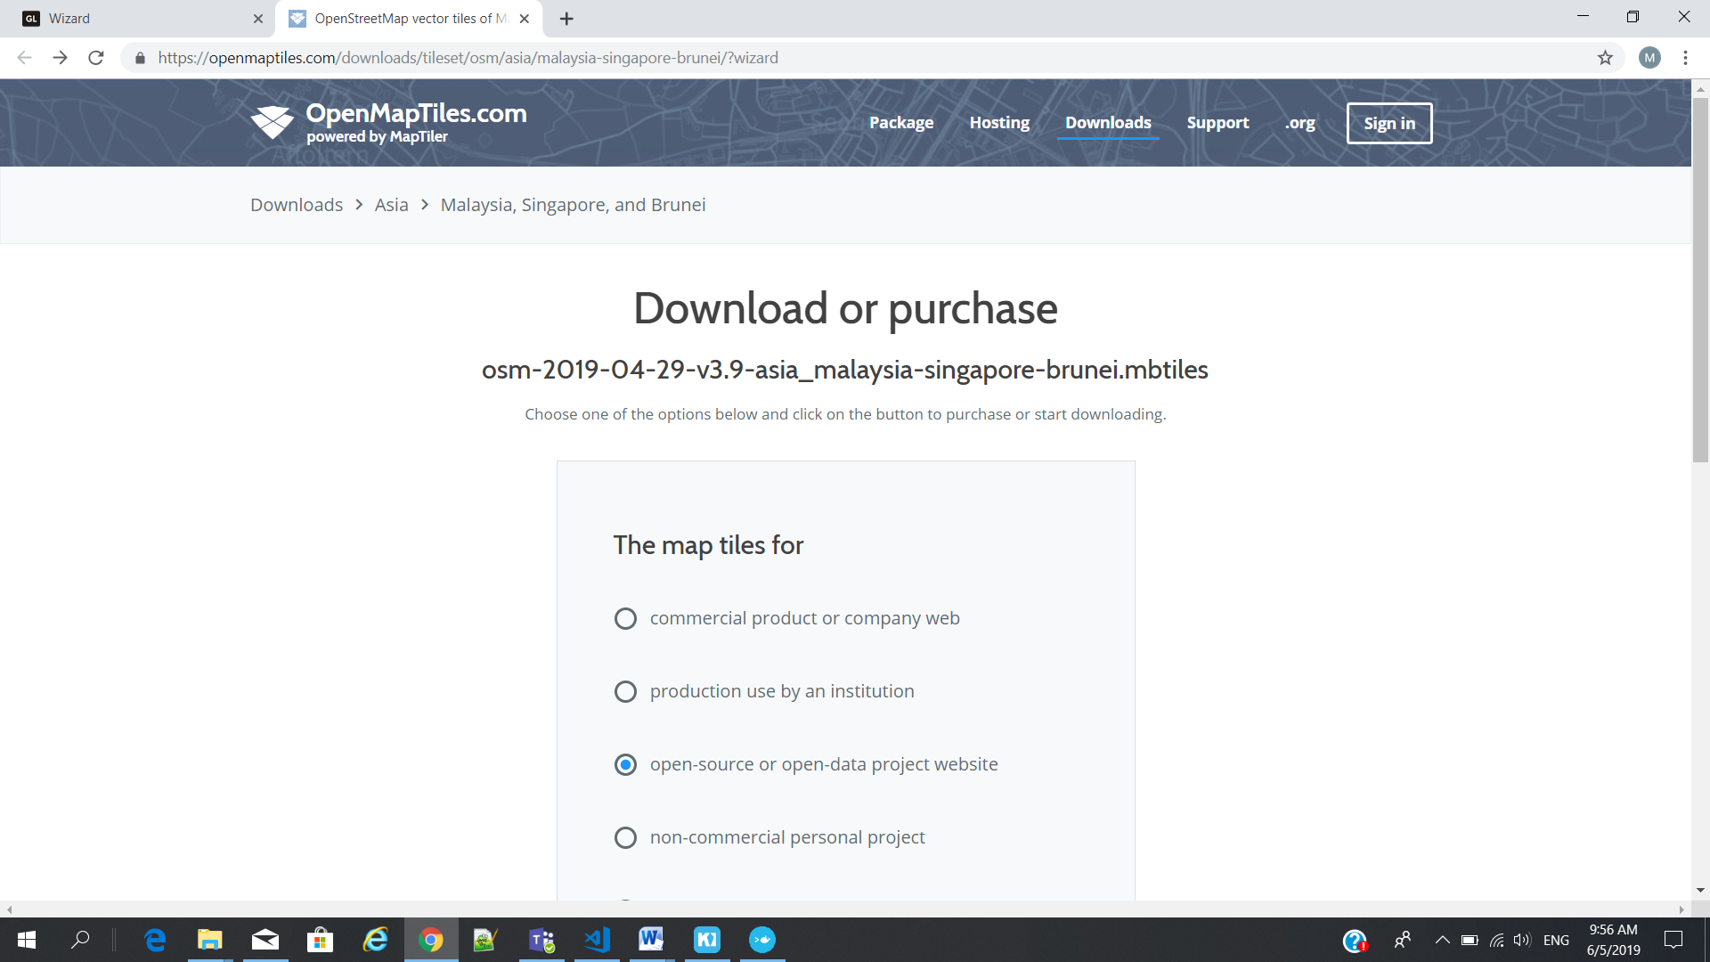

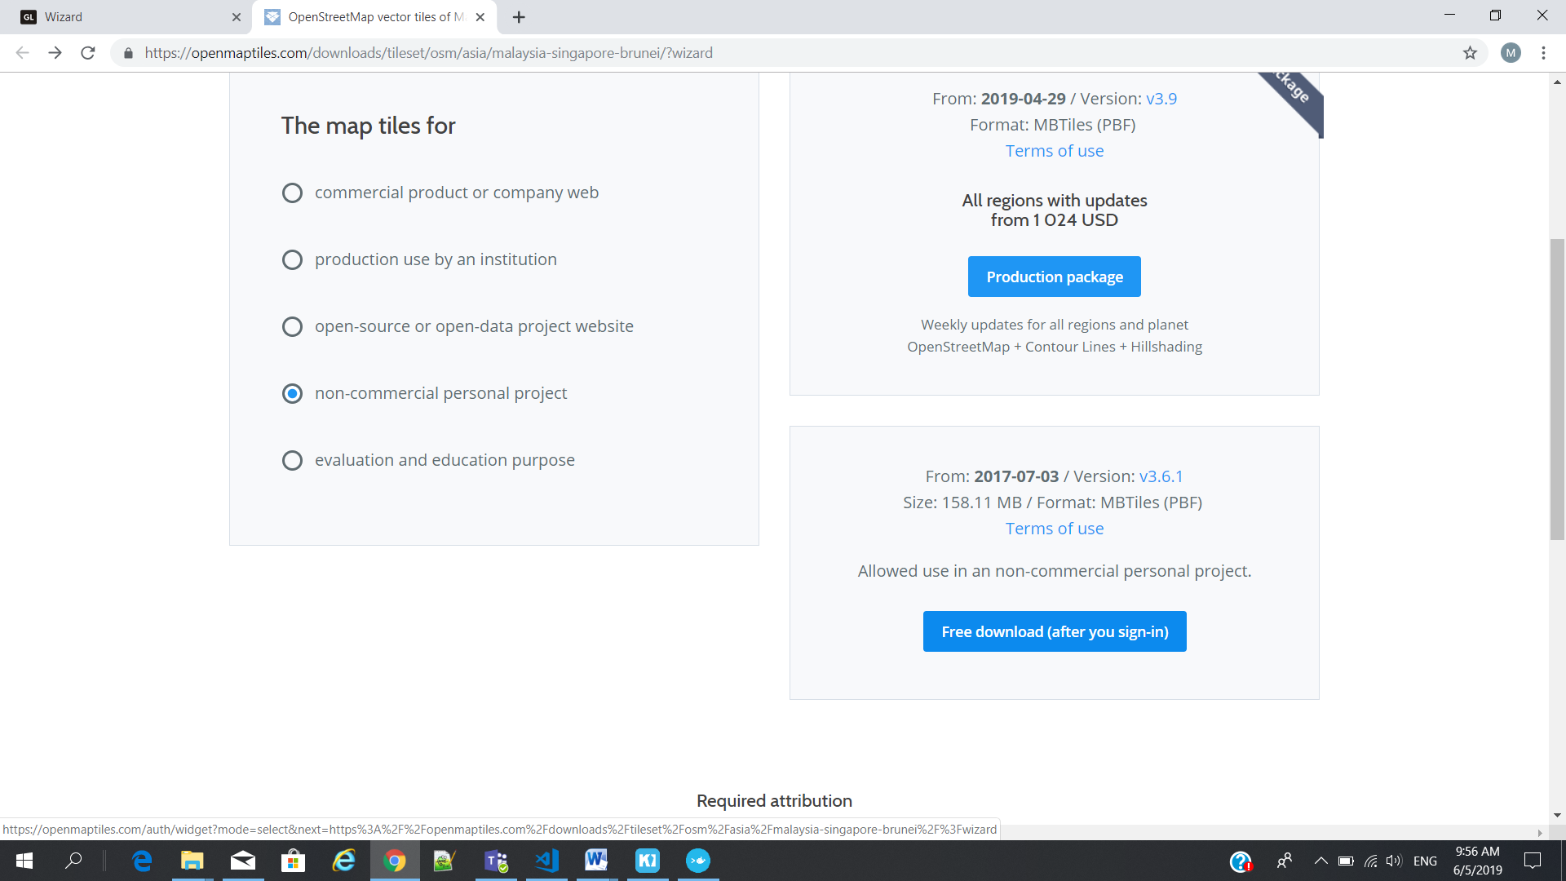

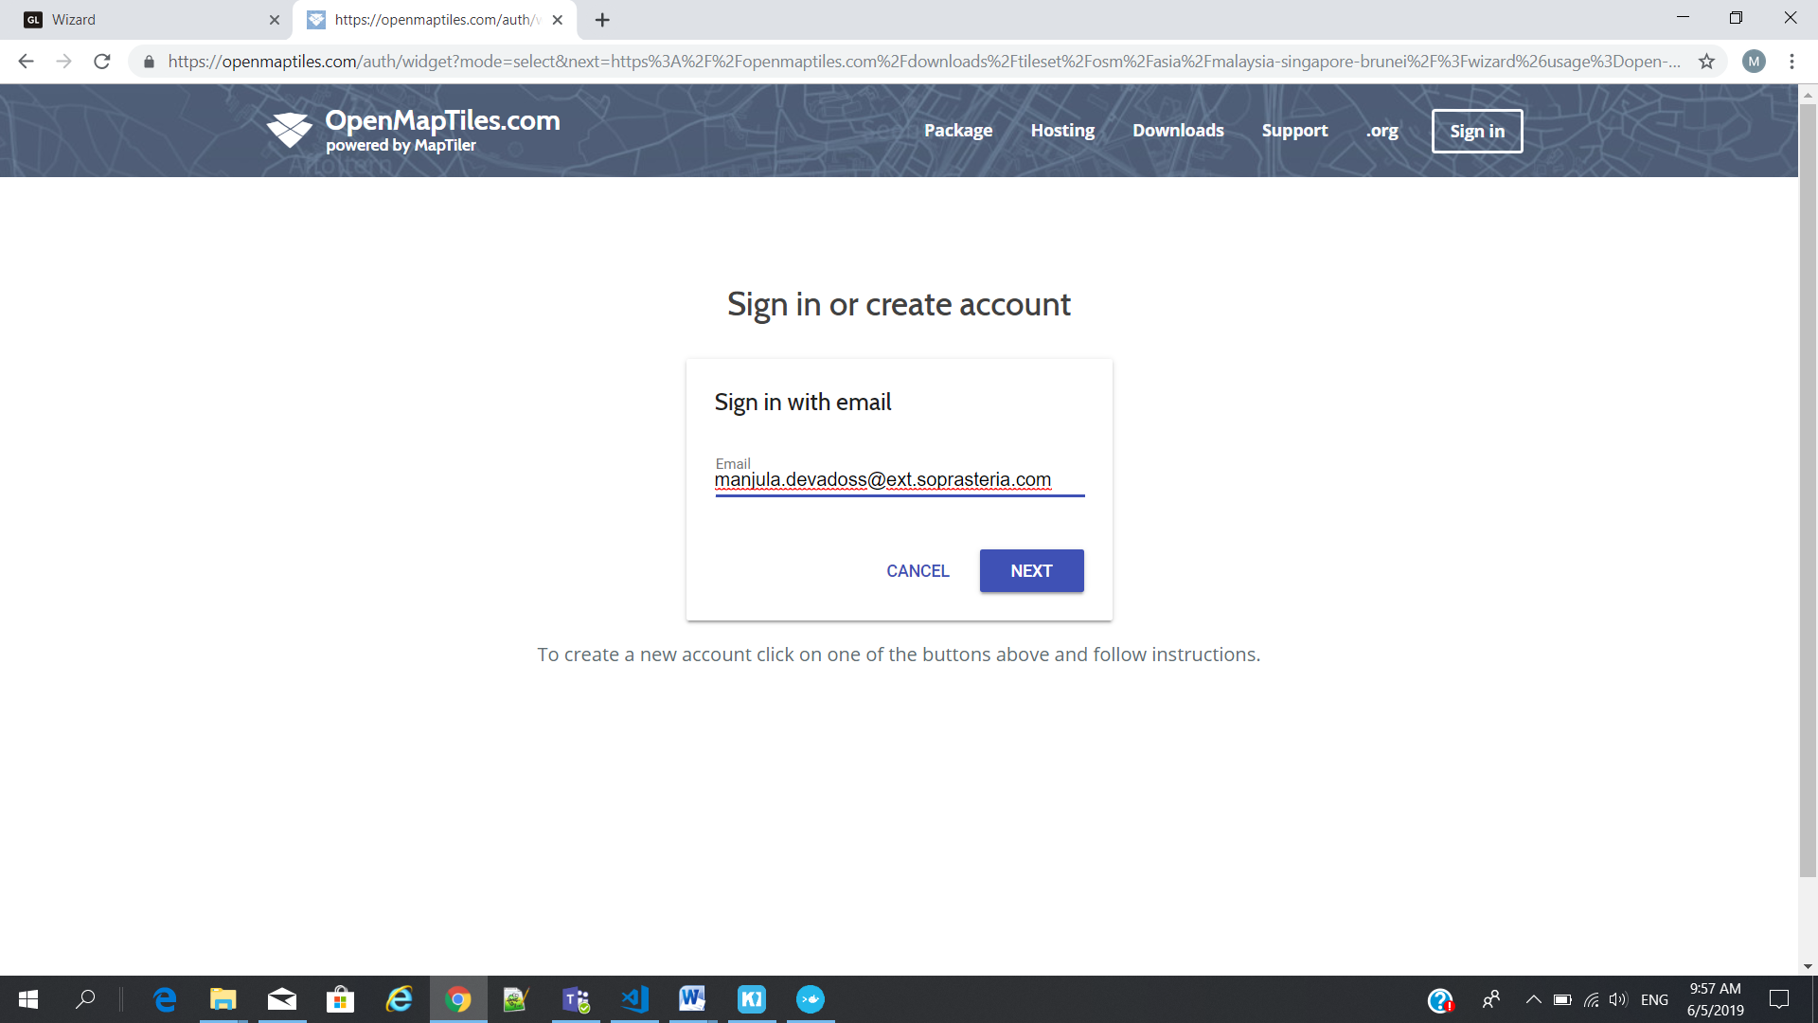

Password : ac@open19

Key : WyJjYWFjYzFkNi03MTIzLTQ5NjMtYWQzZC0zNGI5ZTIyOWZlZWIiLCItMSIsODg2OF0.XT6Yxw.NotKfS7yXNmKYAzczjmdtuq7YbM

# Postgres Database Creation

## Installation

Username : postgres

Password : postgres

port : 5432

## Open Postgres DB

Pgadmin III – from start menu

## Create Database

1. Right click from Batabases(3)
2. Choose new Database

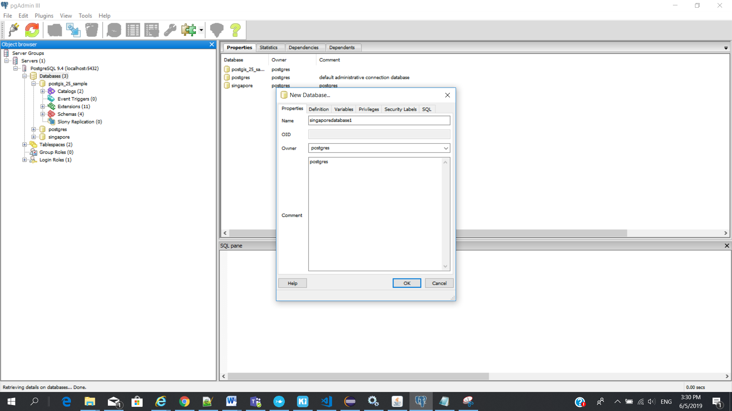

Template as - "postgis_25_sample"

Tablespace - pg_default

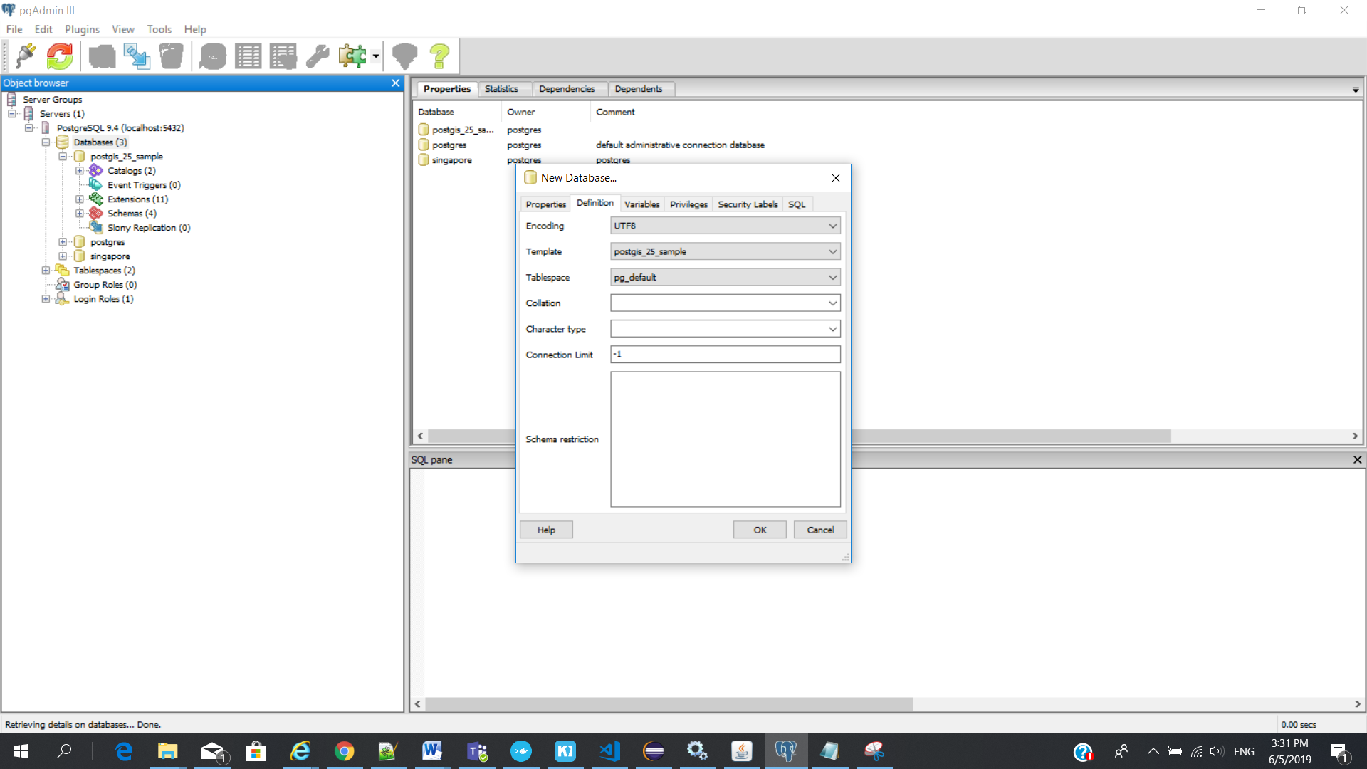

Make sure when you choose “postgis_25_sample” - Disconnect Database – cross icon on the label name

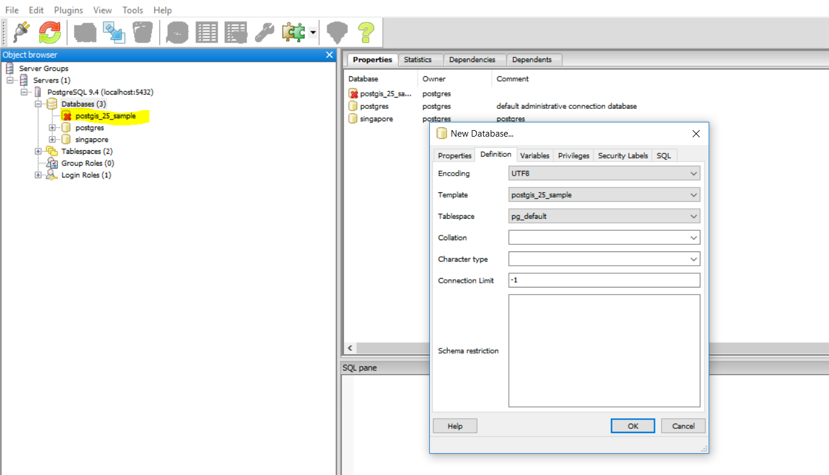

New database : singaporedatabase1

---- Singaporedatabase1

-------- Schemas

---------- Tables

--------- pointcloud_frmats(table)

---------- saptial_ref_sys(table)

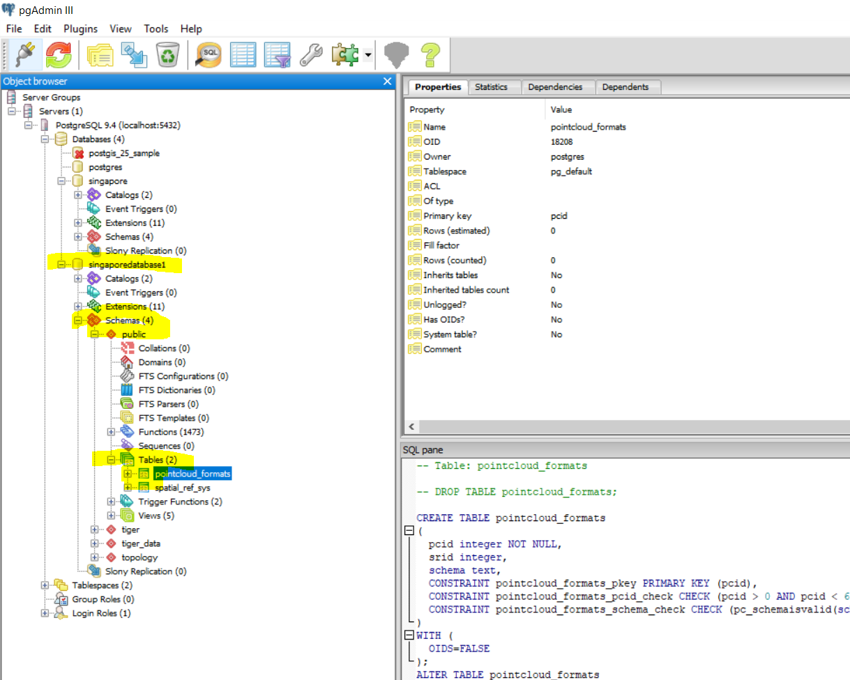

## Run SQL Editor – View Data

Use SQL option

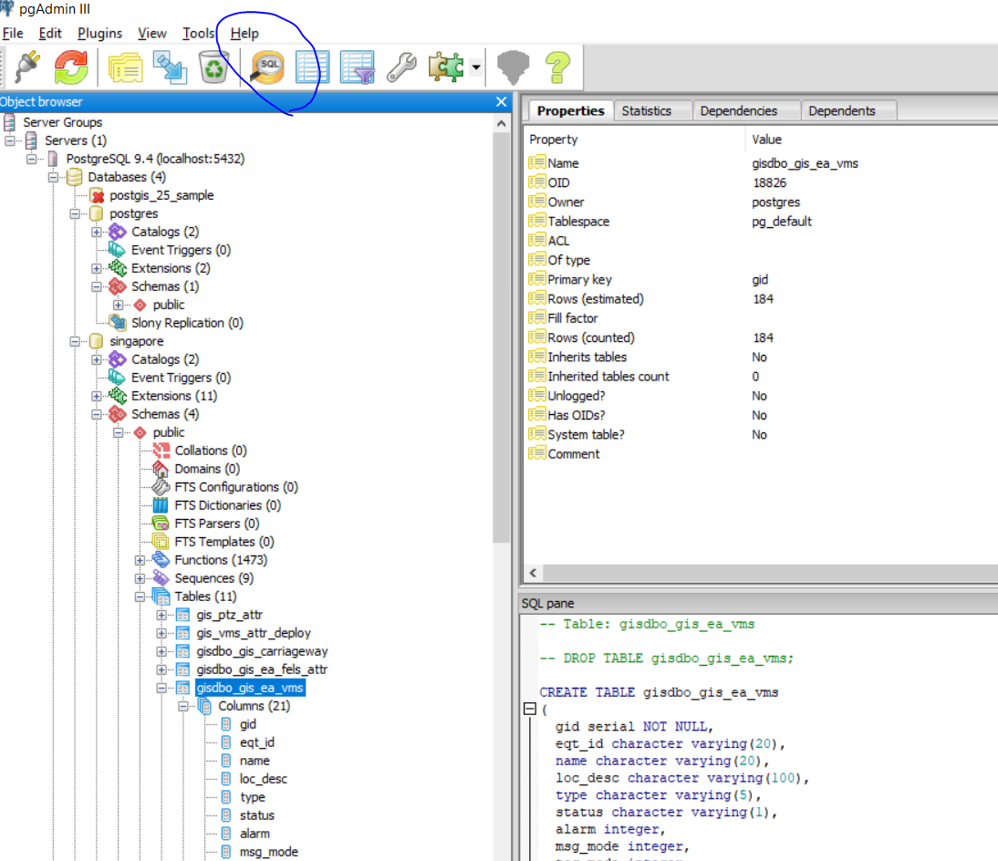

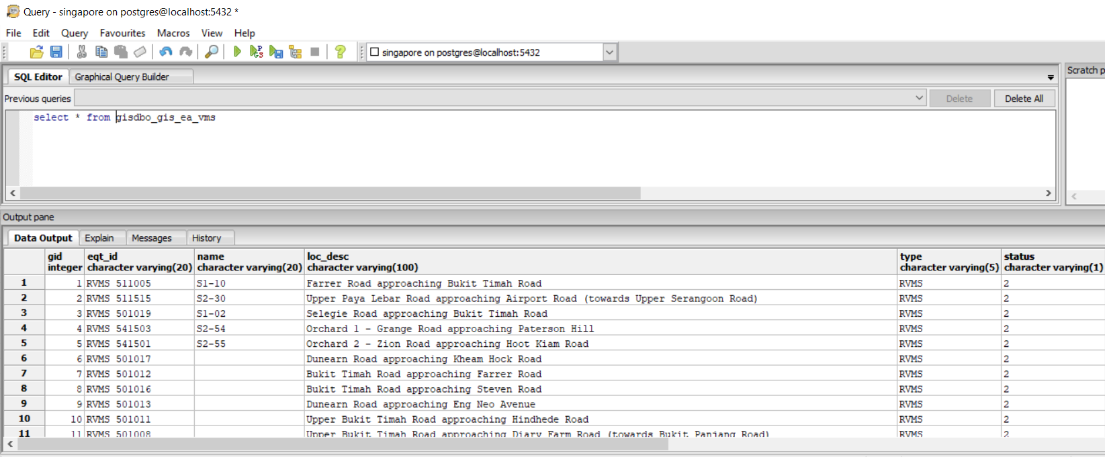

To get the row

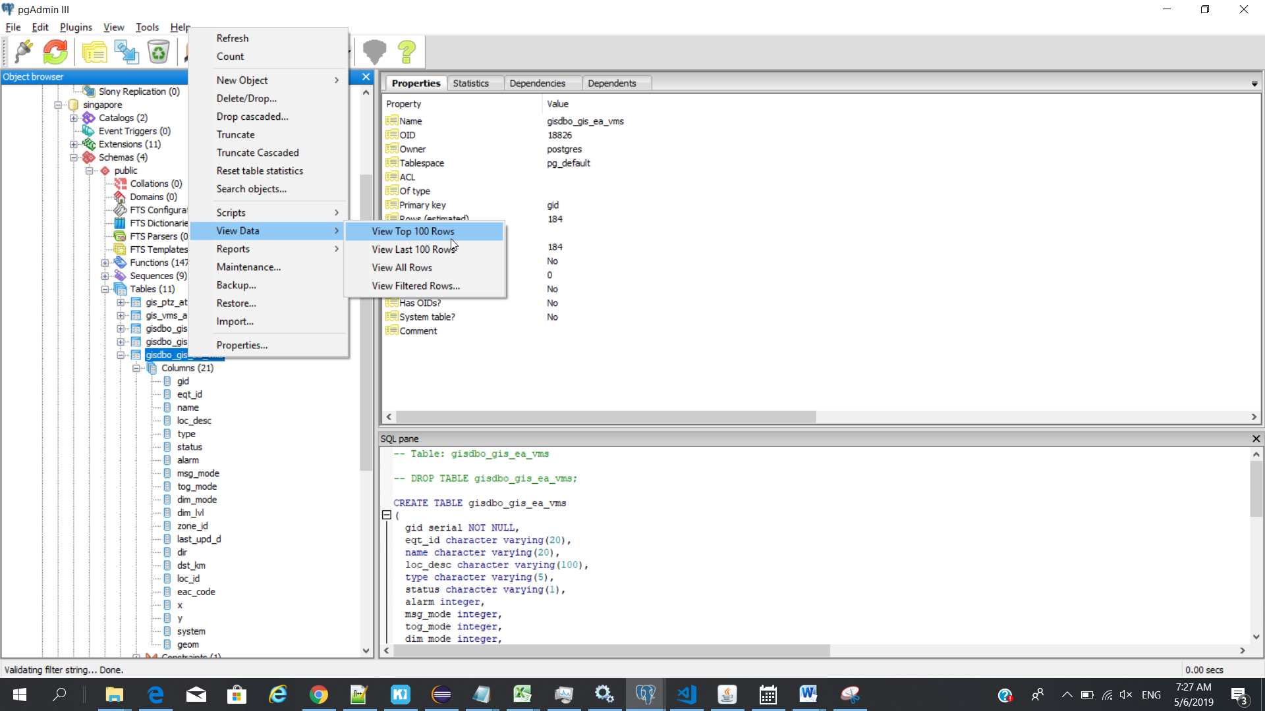

## Import table

Note: 1. after import/create new table need to configure in Geosever for that

1. Create Layer from Geoserver for the corresponding table
2. Choose Menu - Plugins - PostGIS Shapefile and DBF loader 2.2

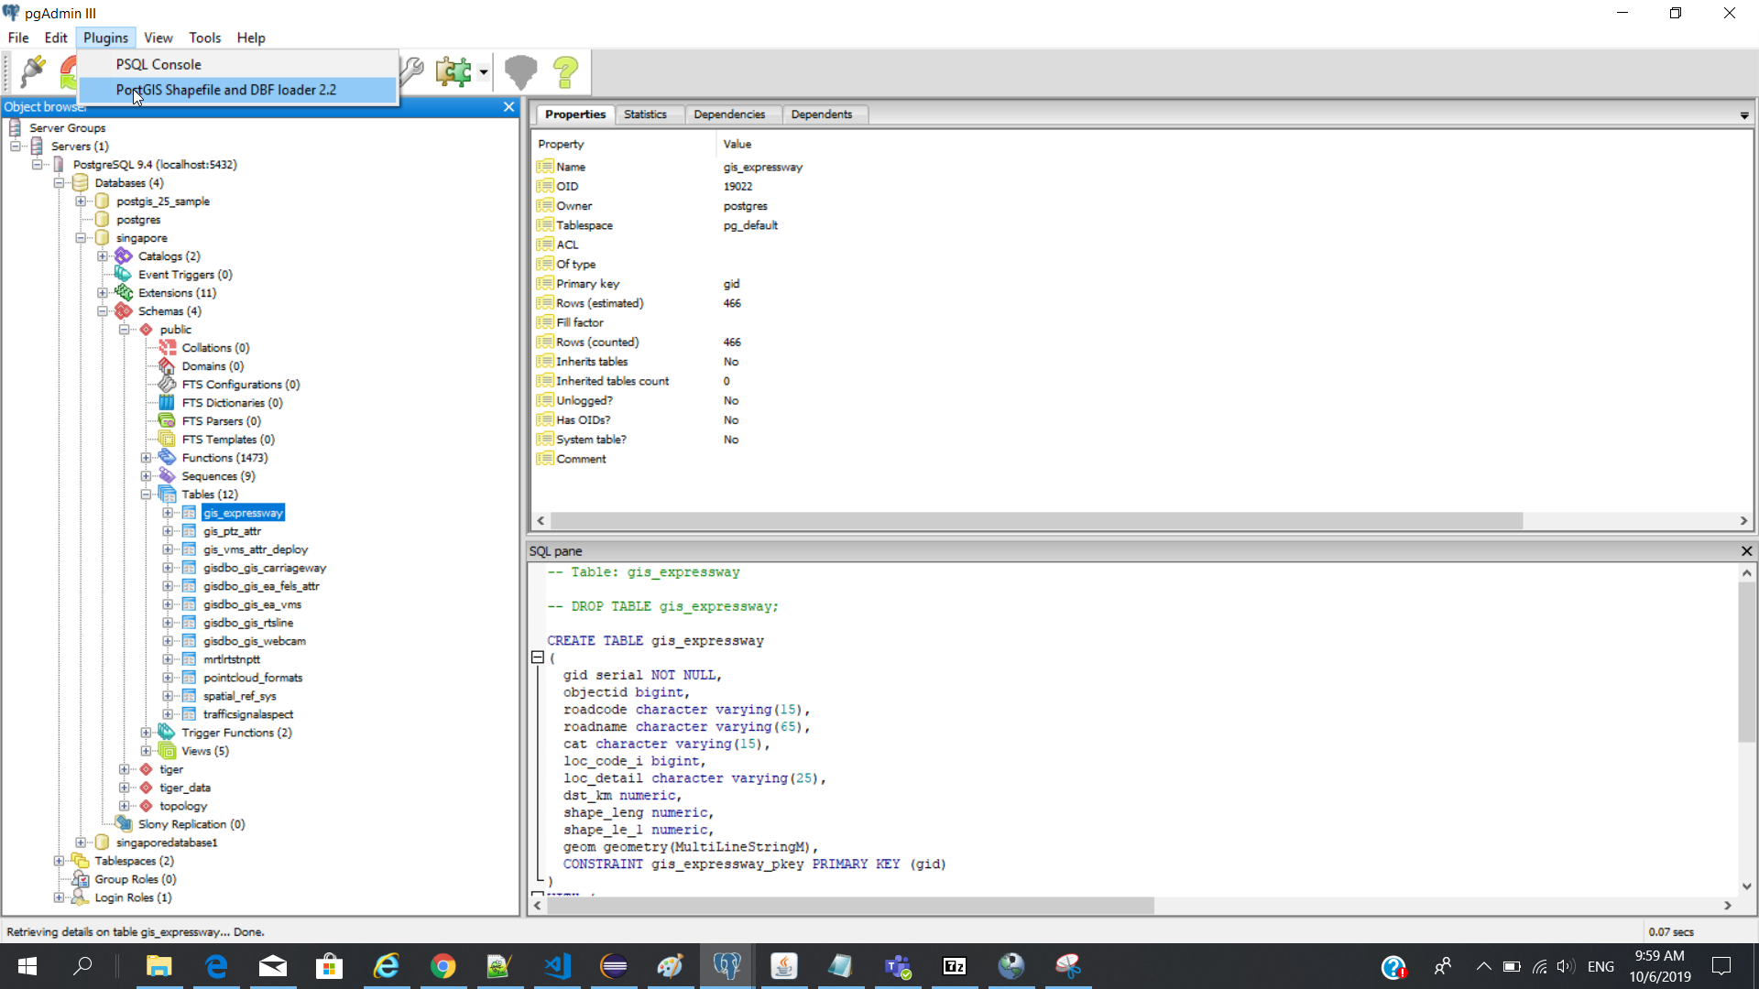

1. Add File

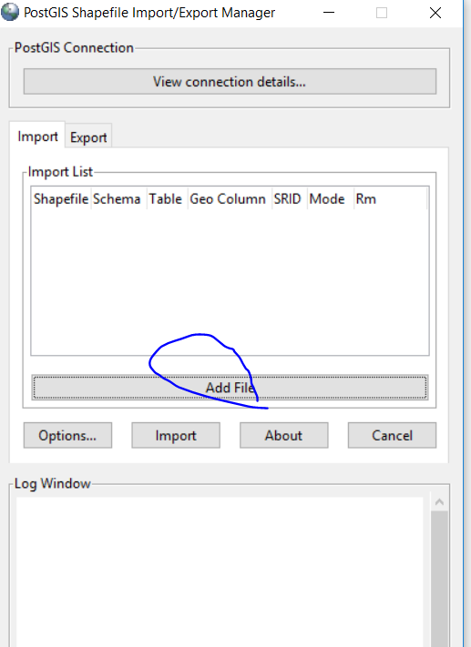

View connection details – to check you correct Database

1. Select your location and click open

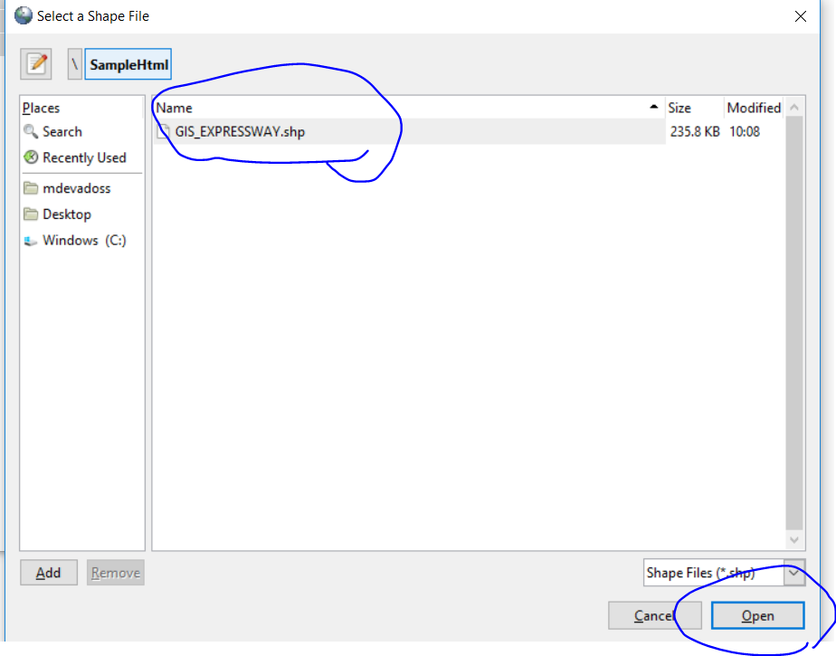

1. Choose your table and Press import

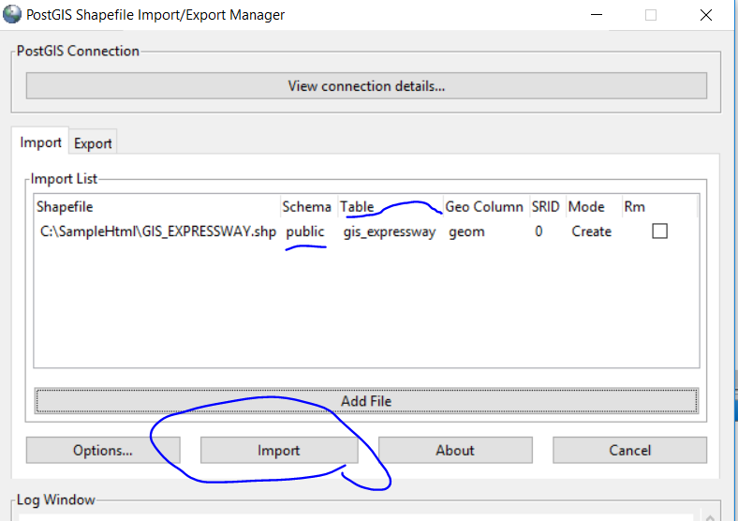

New table imported

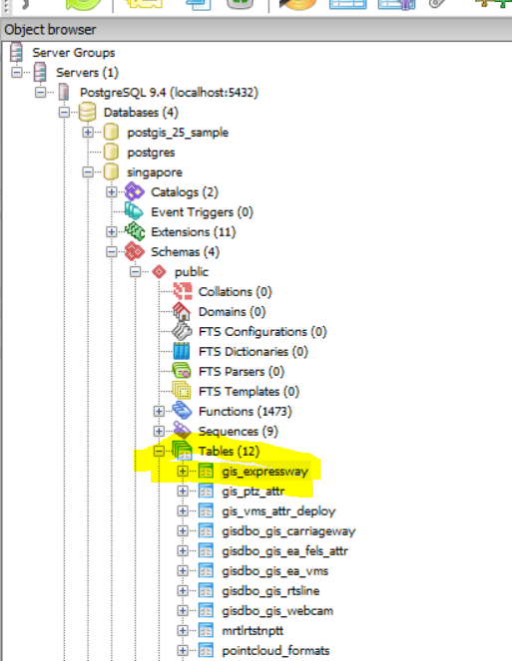

# DBeaver SQL client

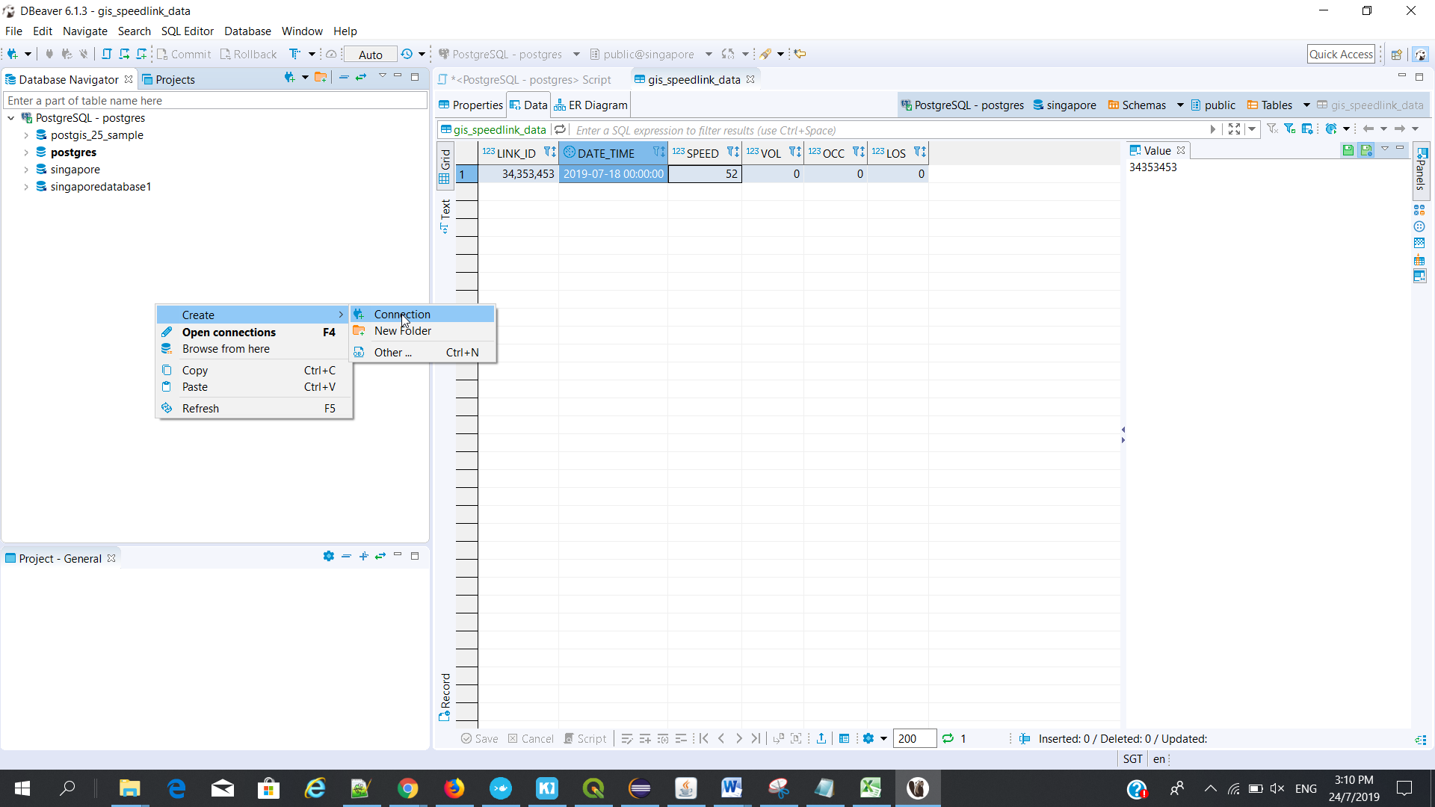

Choose your database

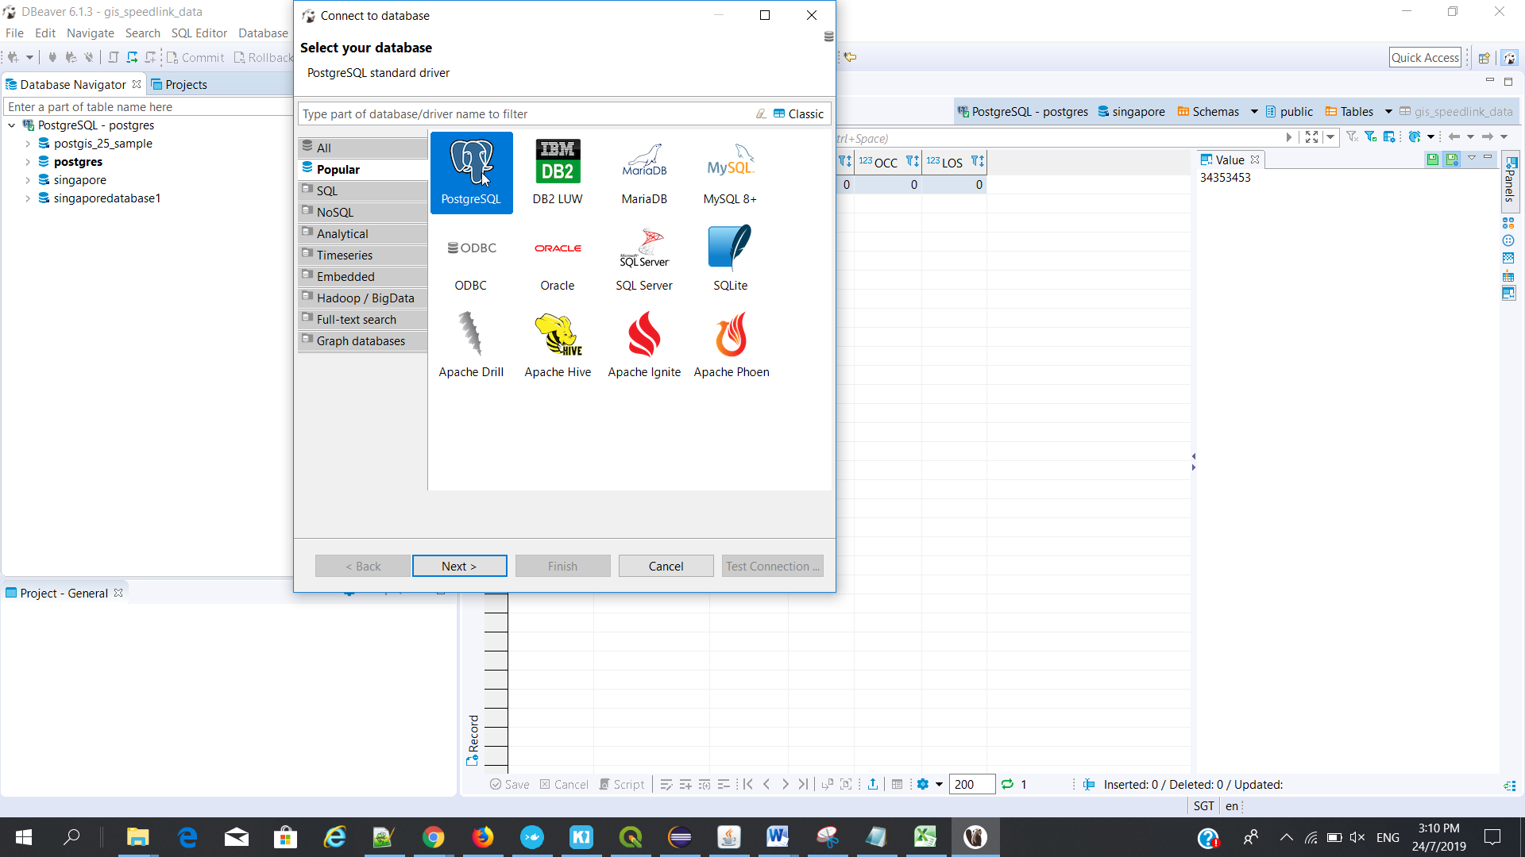

# Geoserver and database setup

## Local Folder Location:

C:\Program Files (x86)\GeoServer 2.15.1\data_dir\workspaces

(Layer and style xml file available in this location)

1. Image Location

C:\Program Files (x86)\GeoServer 2.15.1\data_dir\styles\images

1. Layer Location

C:\Program Files (x86)\GeoServer 2.15.1\data_dir\workspaces\singaporedb

## Online URL

<http://localhost:8088/geoserver/web/;jsessionid=node0x97hx74vffs713topd1s3g0ry13.node0>

## Installation

1. Install the server
2. Got service
3. Choose – geo server – start
4. Change port : 8088

Configure layers in geo server :

Login to Geoserver ()

Click Workspace

Add new workspace

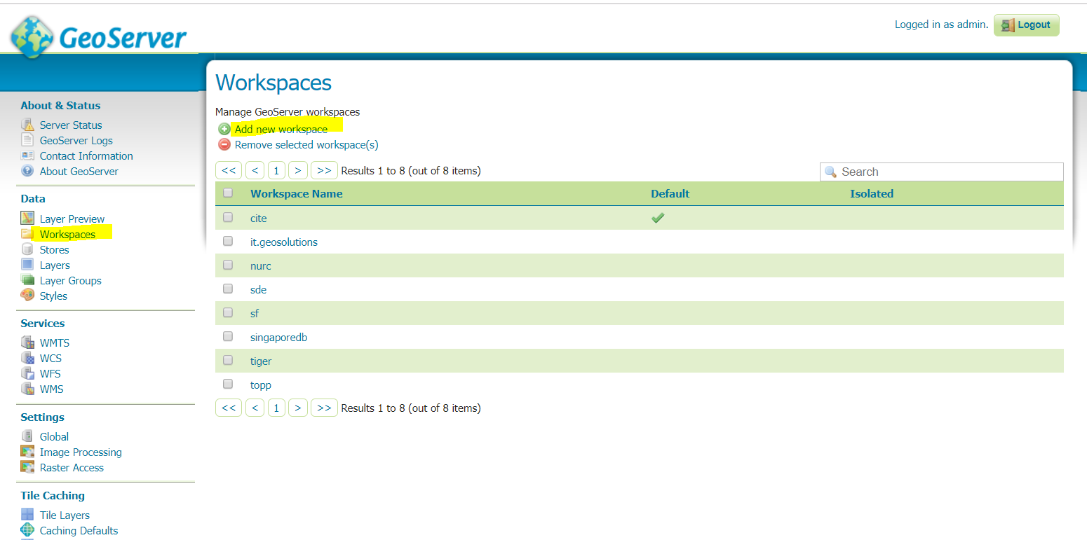

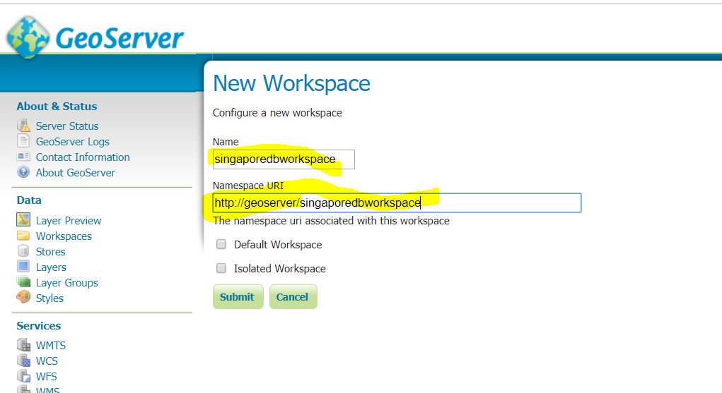

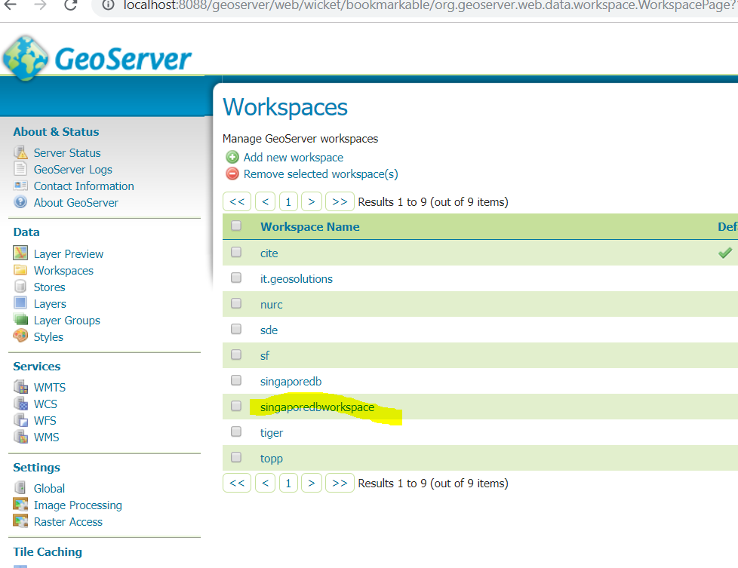

Services :

WMTS – Basemap (openmaptile server)

WMS – Additional layer (geoserver)

1. Click stores

Add new store

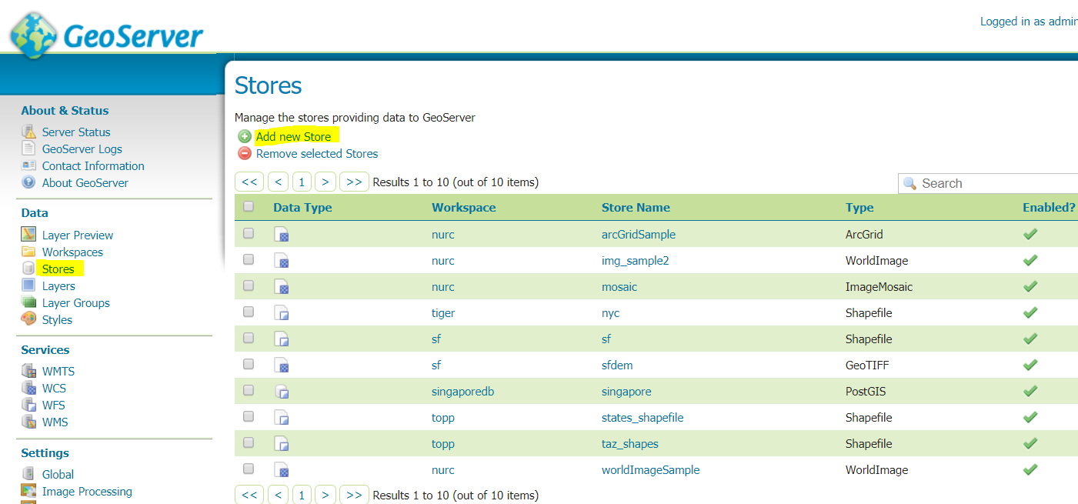

Choose :  [PostGIS](javascript:;)- PostGIS Database

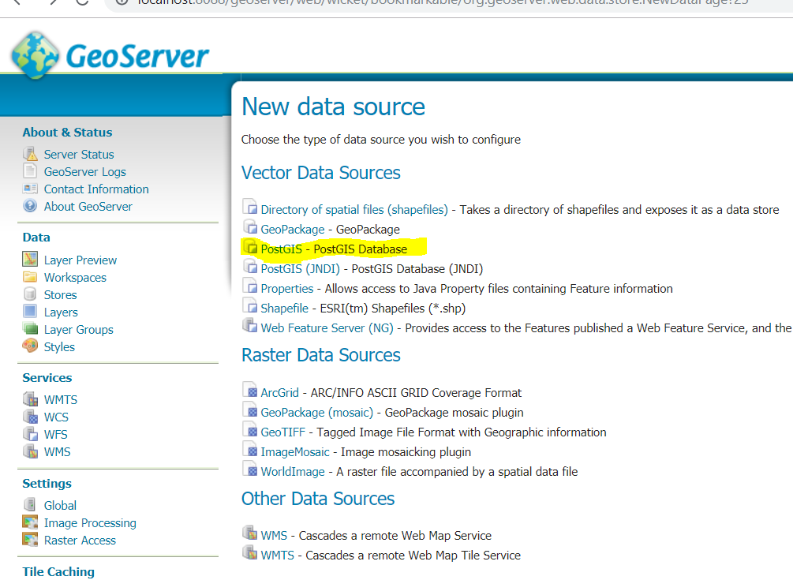

Click stores

Workspace – choose your workspace

Data Source Name – choose your data base name

Database – name of your database

User : postgres

password : postgres

maxconnection : 20

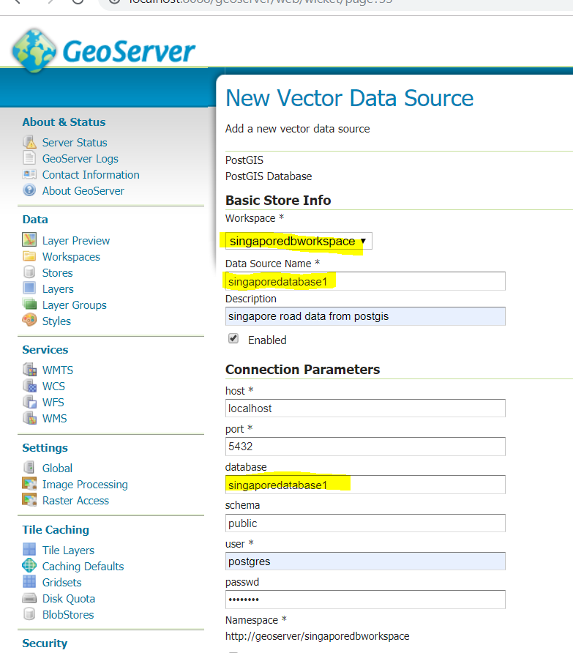

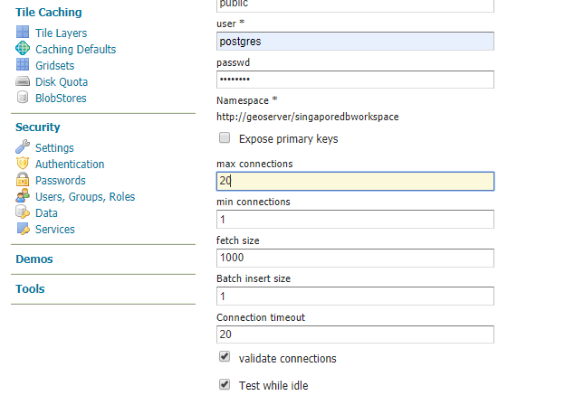

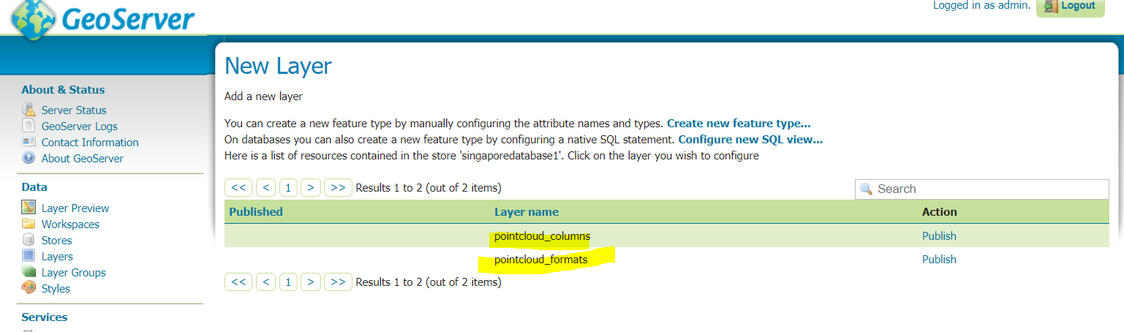

Layer will display : pointcloud_columns table (check with postgres db)

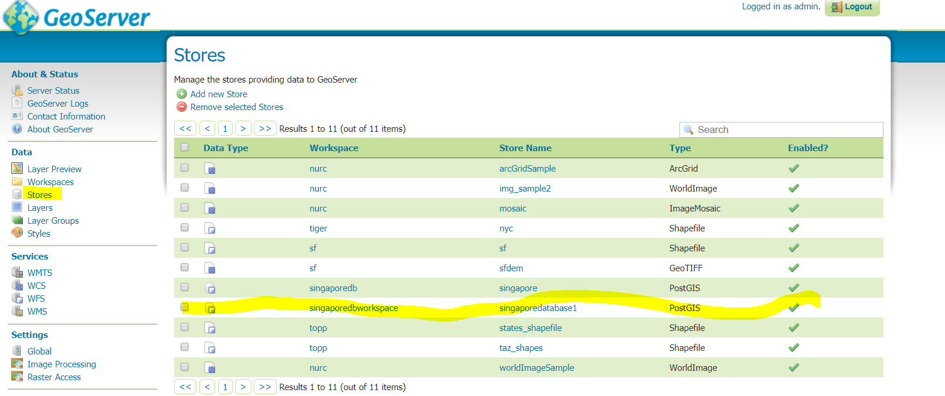

1. Click Layer

Add a new layer

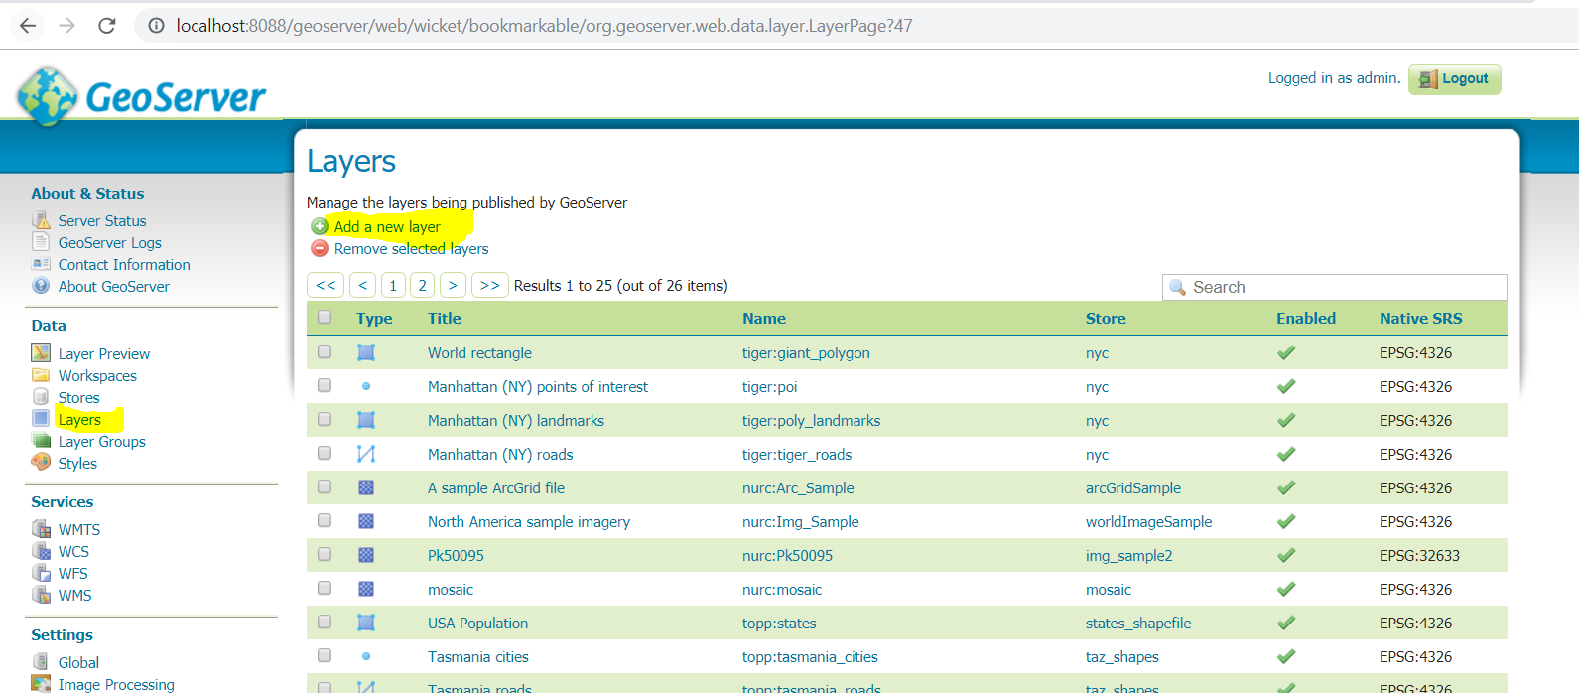

Choose you workspacename

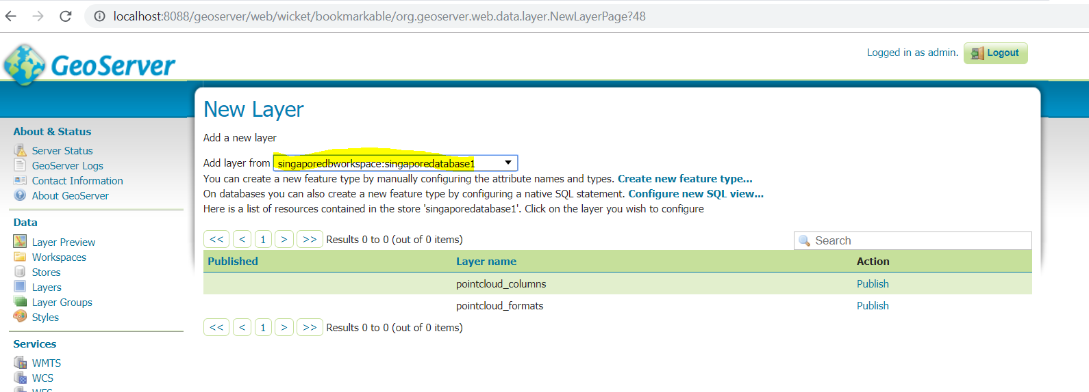

1. Click Layer Preview – to view the layer on the map

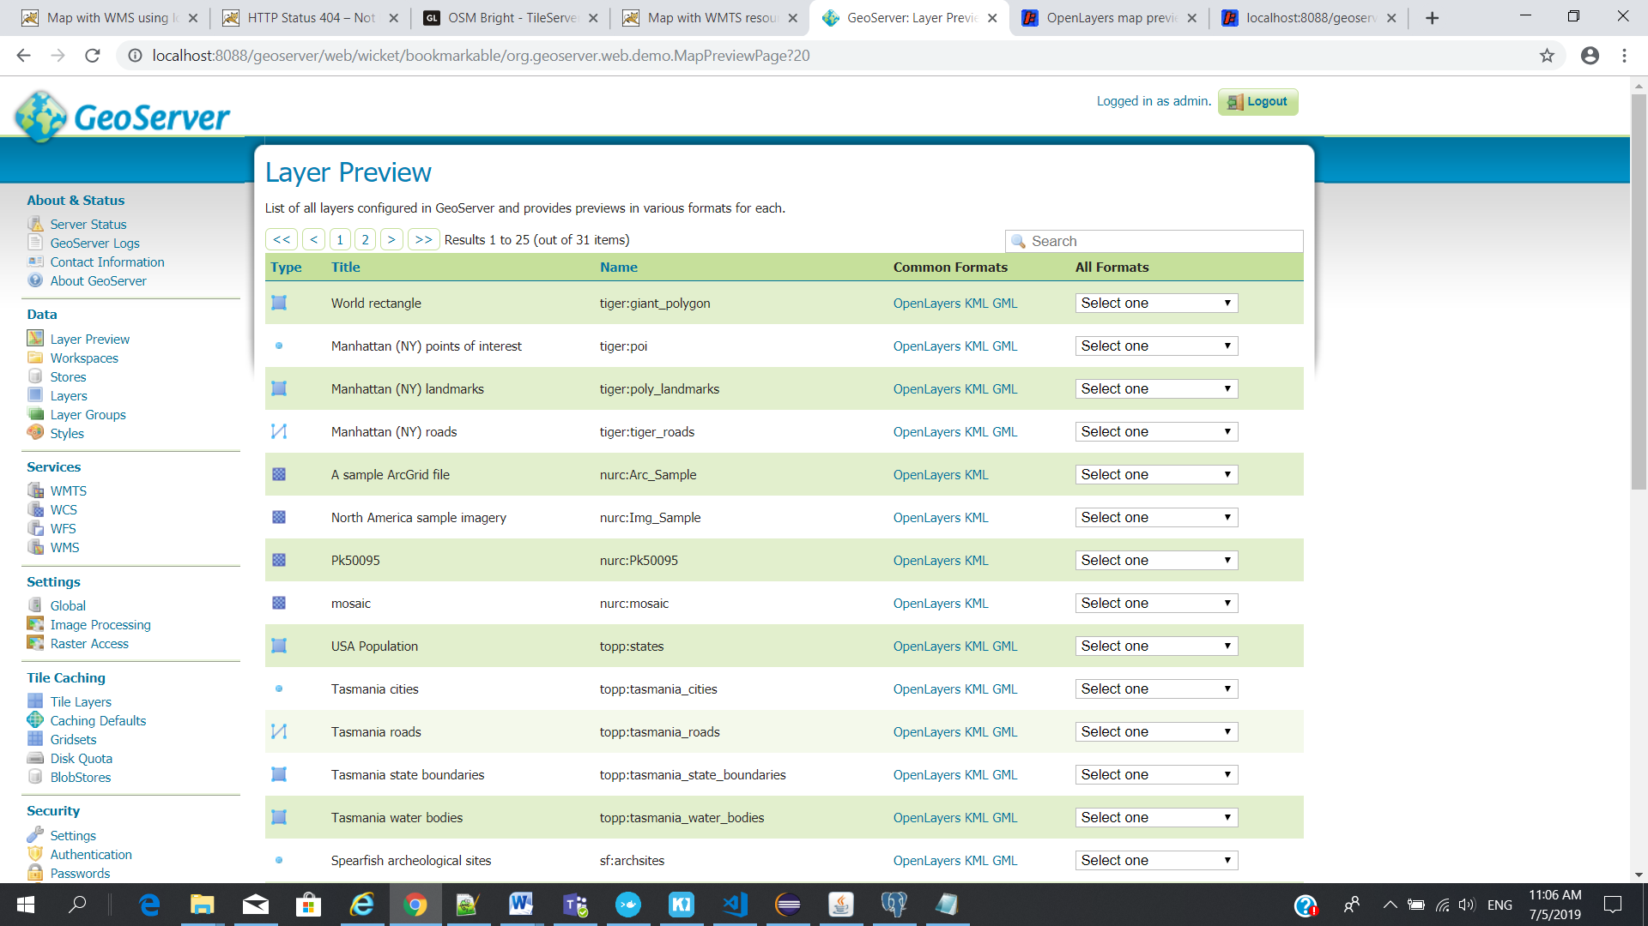

# GeoServer Working Notes

## Database Table and Geo server setup

1. Clone (copy) the existing table (which has layer in already)
2. Add or alter the necessary column
3. Insert or update the records
4. Goto GeoServer
5. Create a new layer using this new table
6. Create a style for the new layer.

## Create New Layer GeoServer

Note: 1. after import/create new table need to configure in Geosever for that

1. Create Layer from Geoserver for the corresponding table
2. Publish Layer
3. Choose Menu – Layer – Add a new Layer

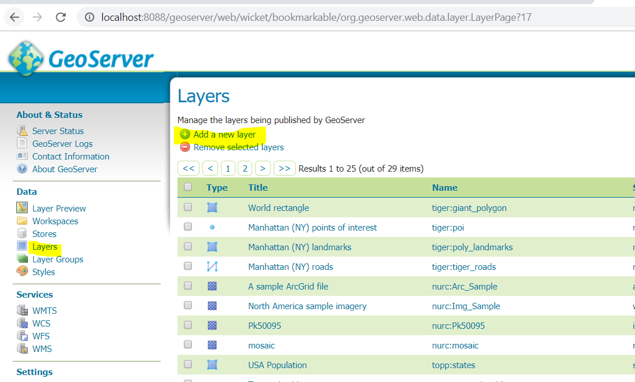

1. Choose a table

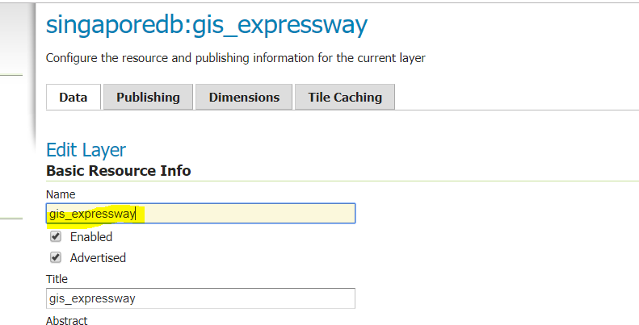

1. Click – Find – type code – 3414 – then select the option

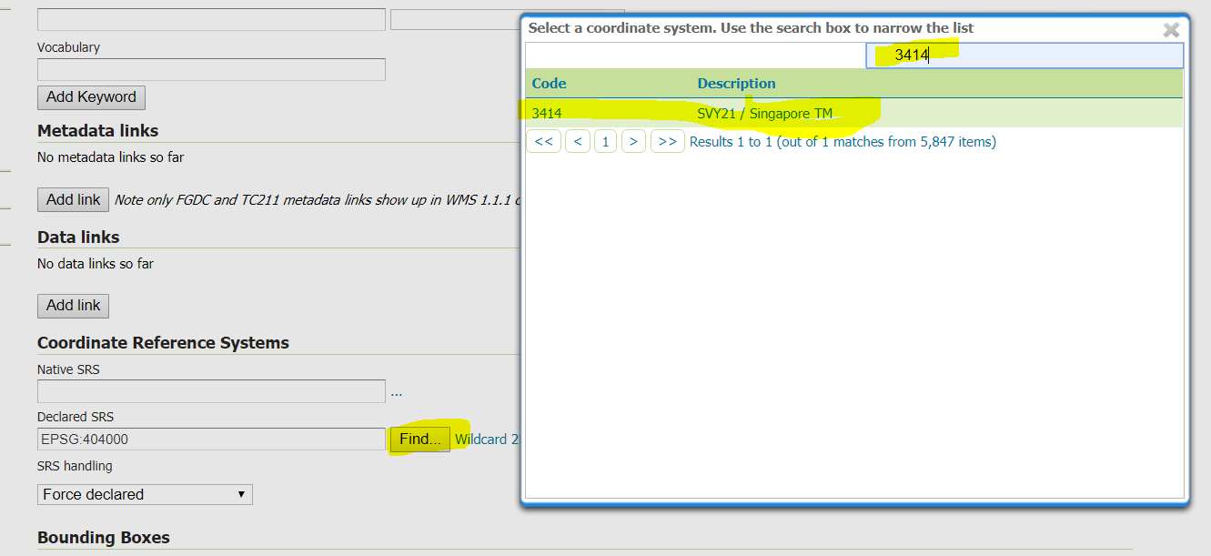

1. Choose - Compute from data for Native Bounding Box, and
2. Choose - Compute from native bounds for Lat/Lon Bounding Box

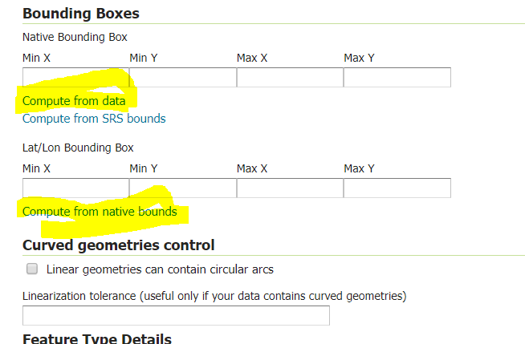

After choosing above option

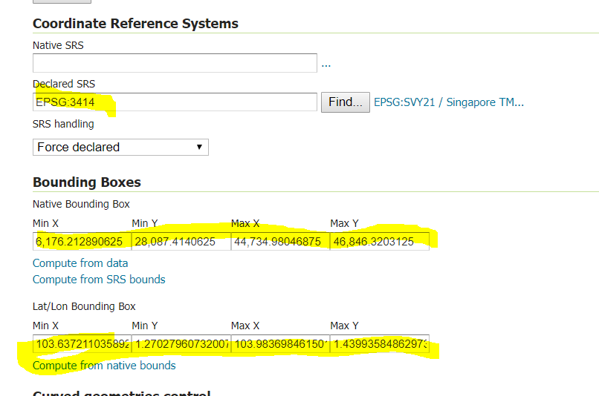

1. Click - Save

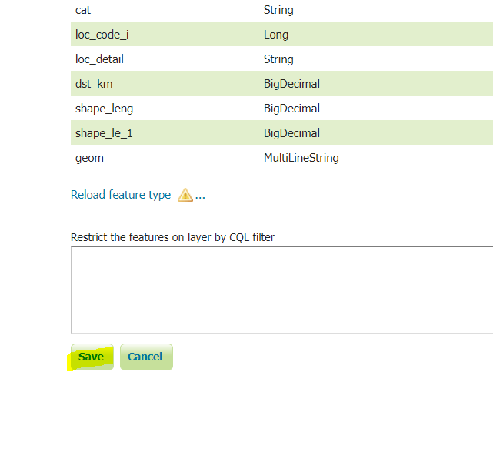

1. Publishing the layer

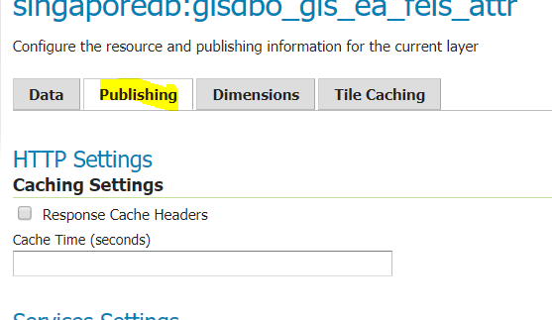

## Layer Preview GeoServer

1. "Layer Preview" : see all the layer name, common formats

2. "Layer Preview"-"OpenLayer" - from the particular layer to view the layer display

3. "Layers" - Add a new layer

4. "Styles" : Mrt_Line_style - to show line

5. "Styles" : Mrt_station_style - to show station (image)

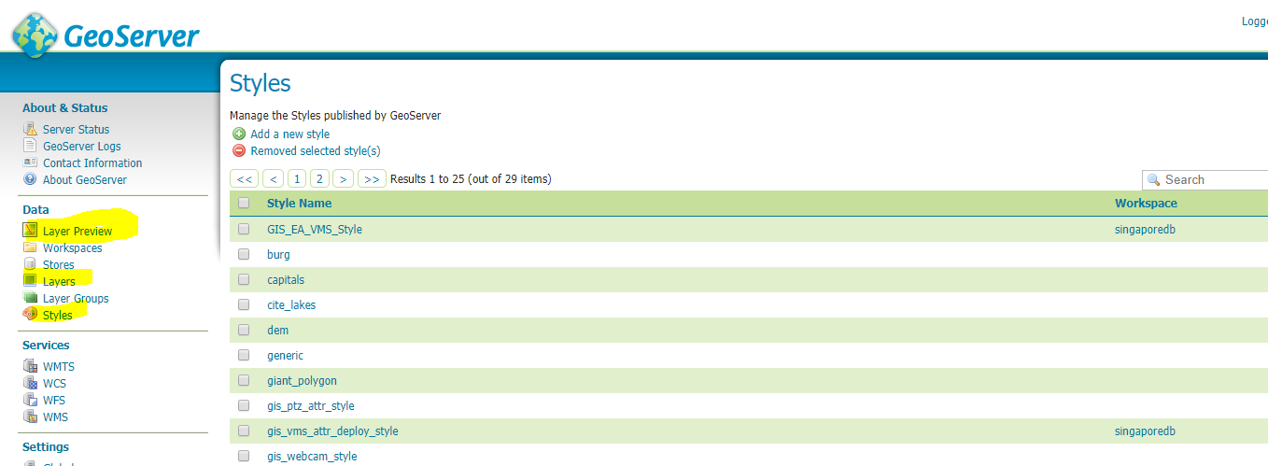

To view the layer view

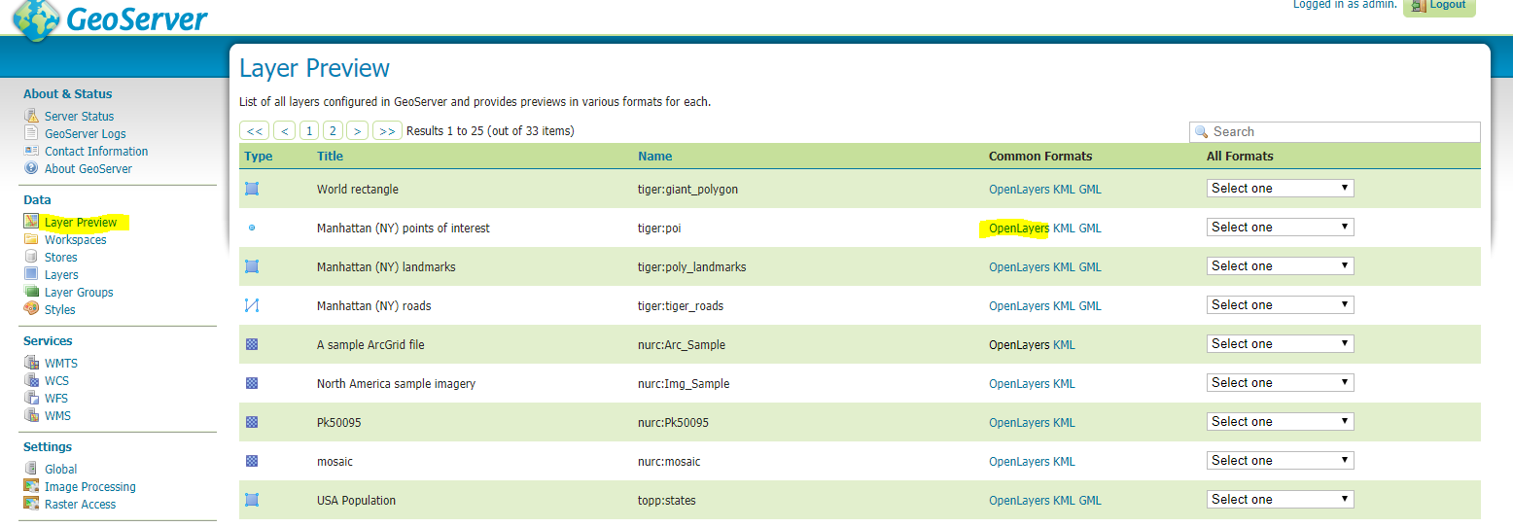

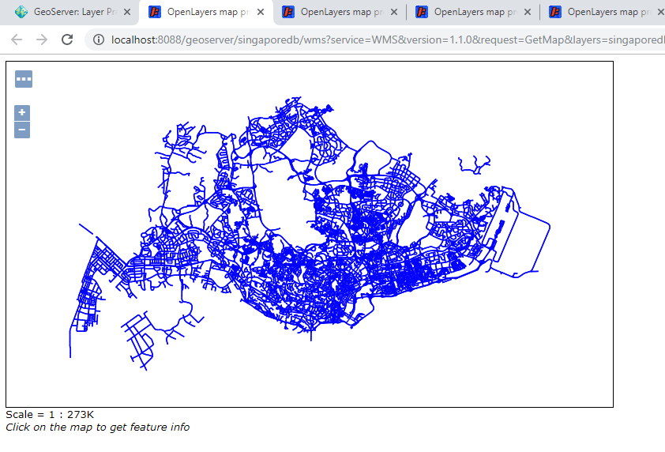

## Create Style

1. After creating a layer create own style for showing particular style
2. Choose – Style – Add a new Style

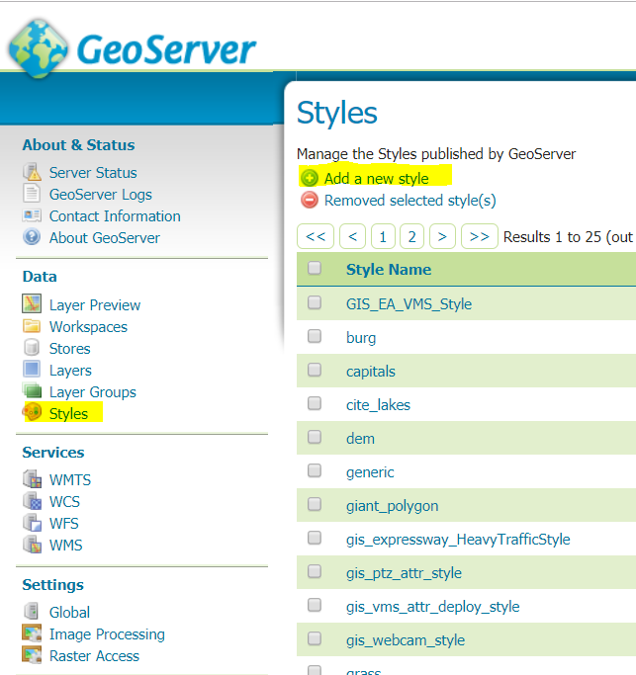

1. Style Data – Name
2. Open from existing style

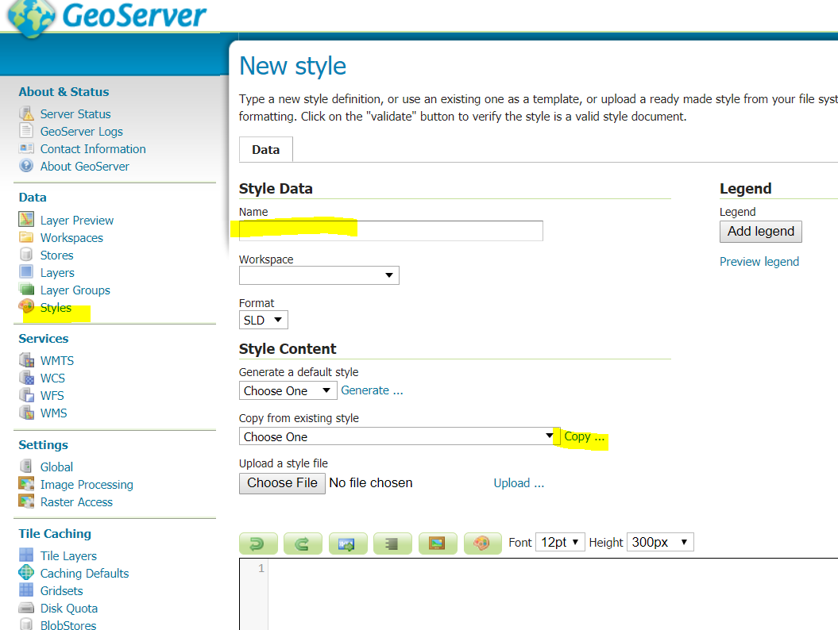

1. Apply

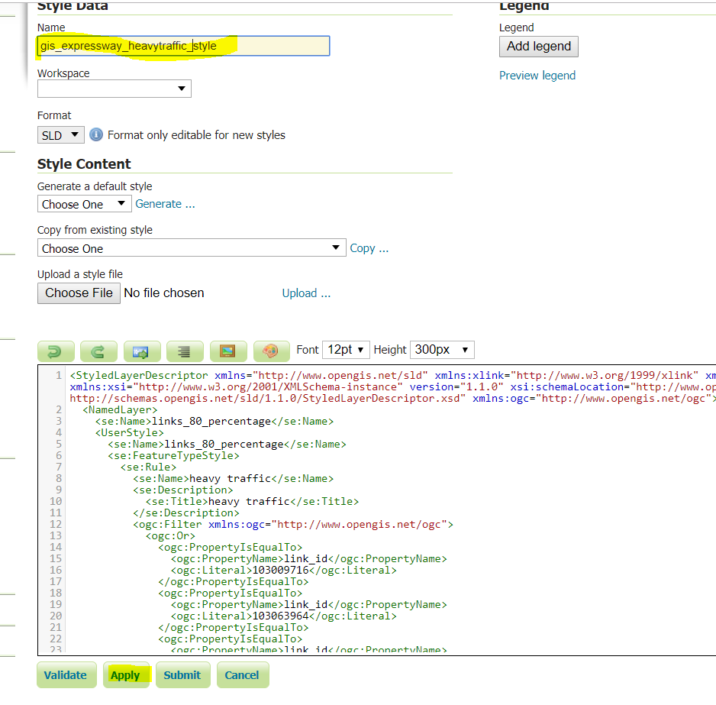

1. After Apply the “Publish” , “Layer Preview”, “Layer Attributes ” button appears

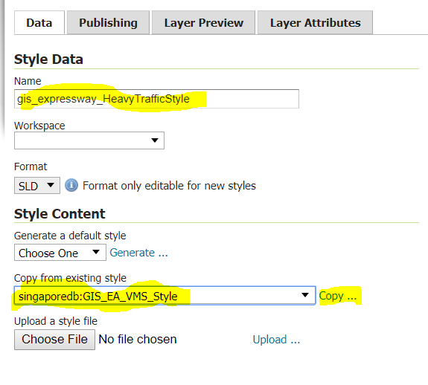

1. Make your style “Default” from Publishing menu by “tick” the option button and “Apply”

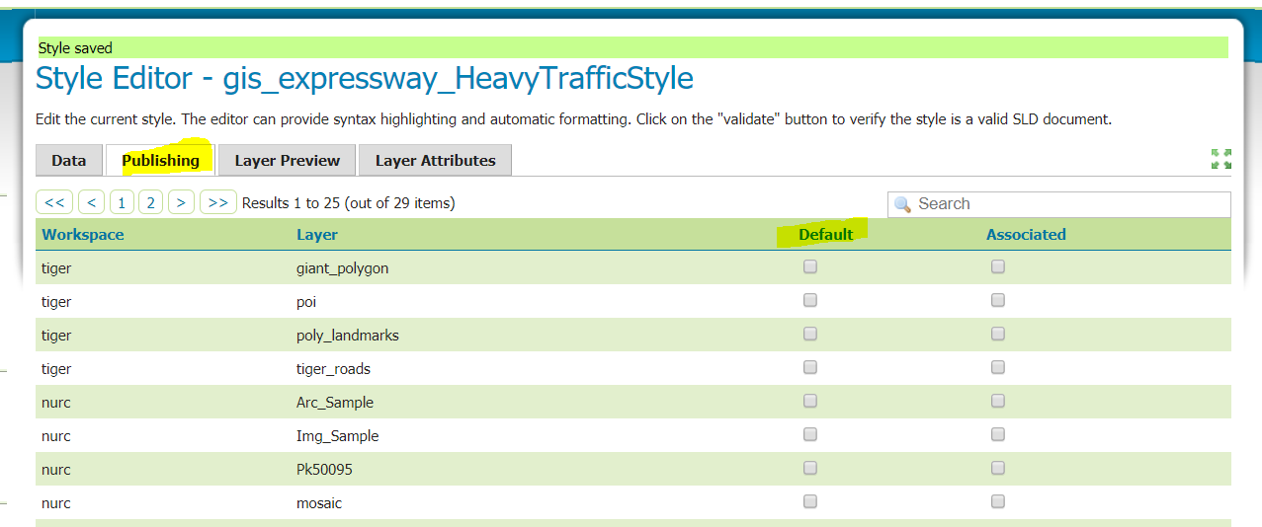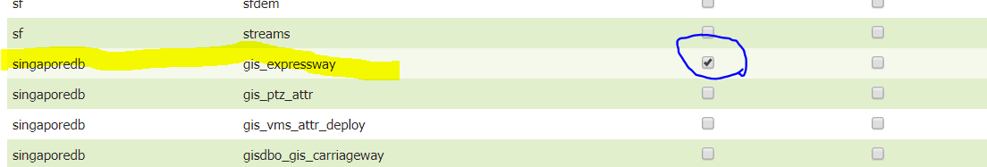

# QGIS Working Notes

This application is used to combine basemap with database. So u can identify location for VMS, road name etc without launch other application.

## Install

QGIS-OSGeo4W-3.6.3-1-Setup-x86_64.exe

## Configure

1. Choose PostGIS – New Connection – Database name in Database column
2. Port : 5432

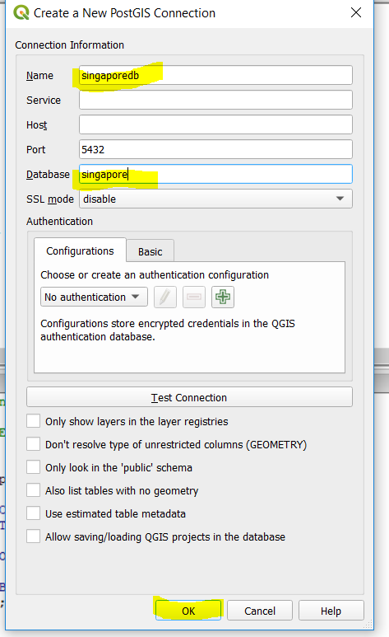

1. Postgres user name and password – postgres/postgres

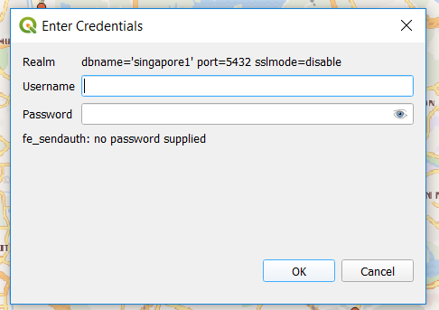

1. Database Created – singaporedb1

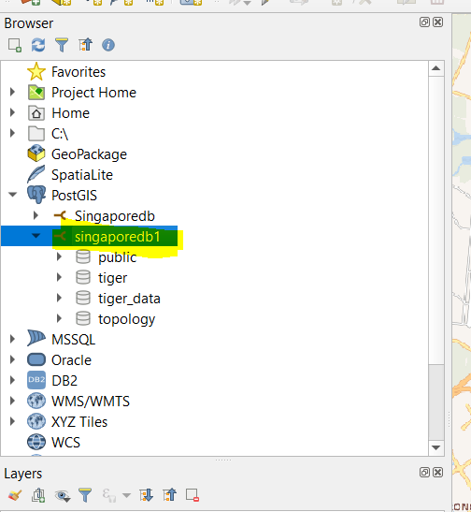

1. Add the Basemap layer –

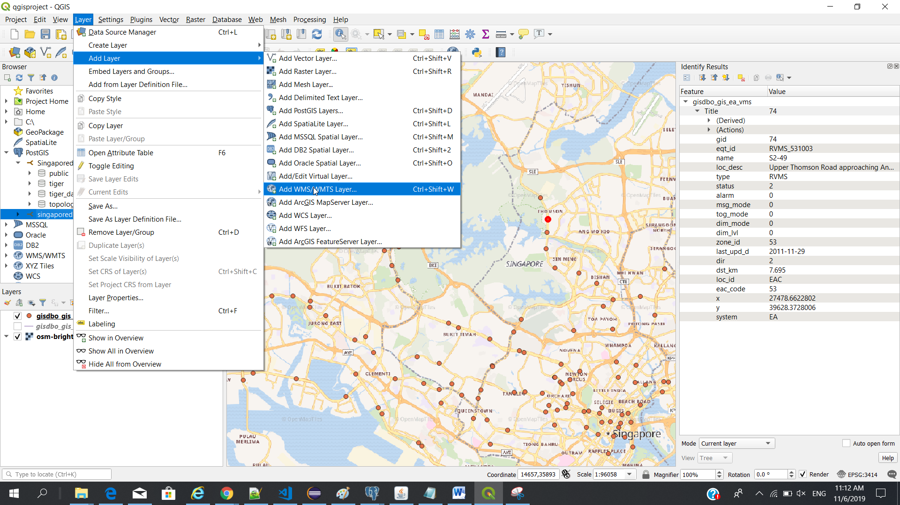

Connect to Openmaptile server to get copy the following URL.

Name : basemap

URL : <http://192.168.99.100:32768/services/wmts?service=WMTS&request=GetCapabilities>

http:// 192.168.99.100:32773/services/wmts?service=WMTS&request=GetCapabilities

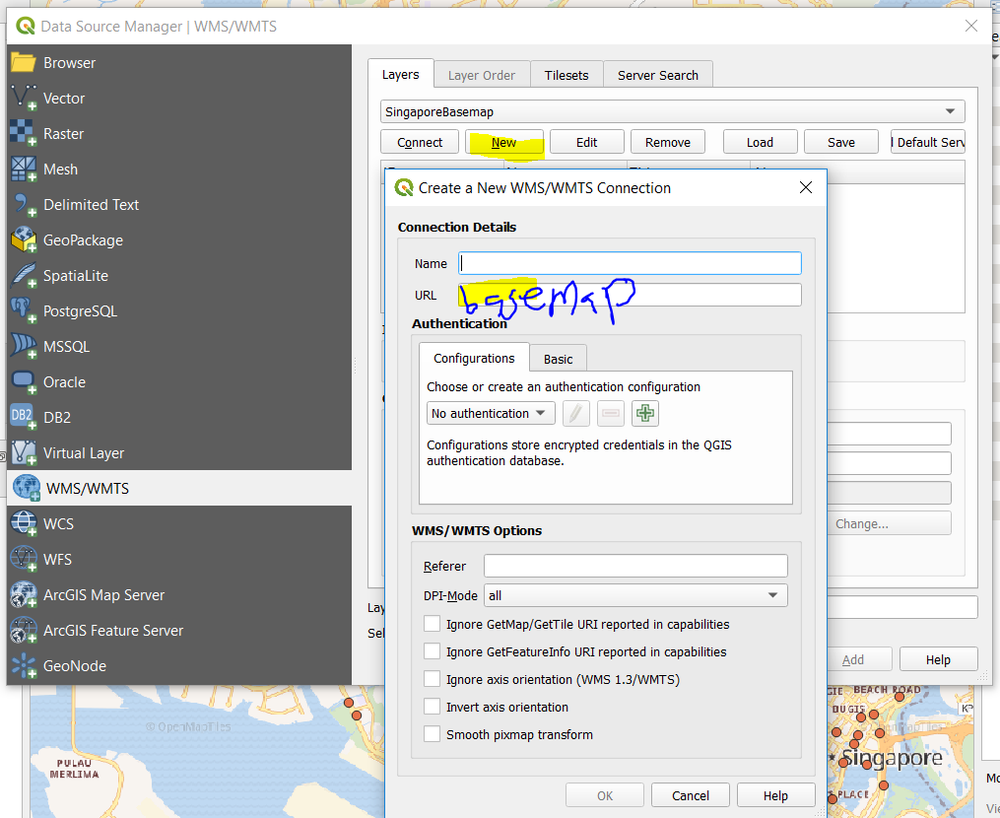

Click Ok

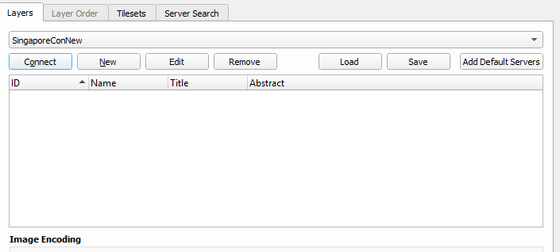

Press “Connect”

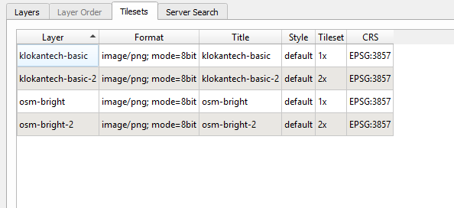

Choose “osm-bright2” and press “add”

1. OSM-bright map layer added

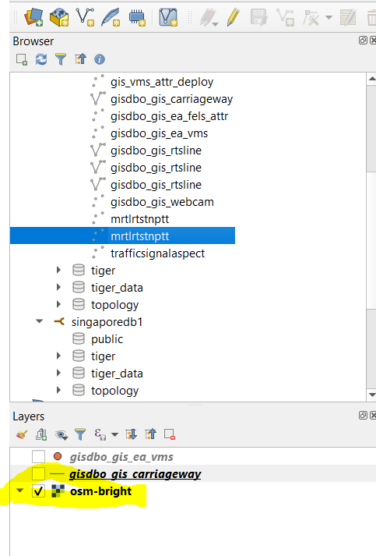

1. Add other layer like VMS, carriage bridge way, mrt station etc
2. Choose the layer and right click – Add Layer to Project

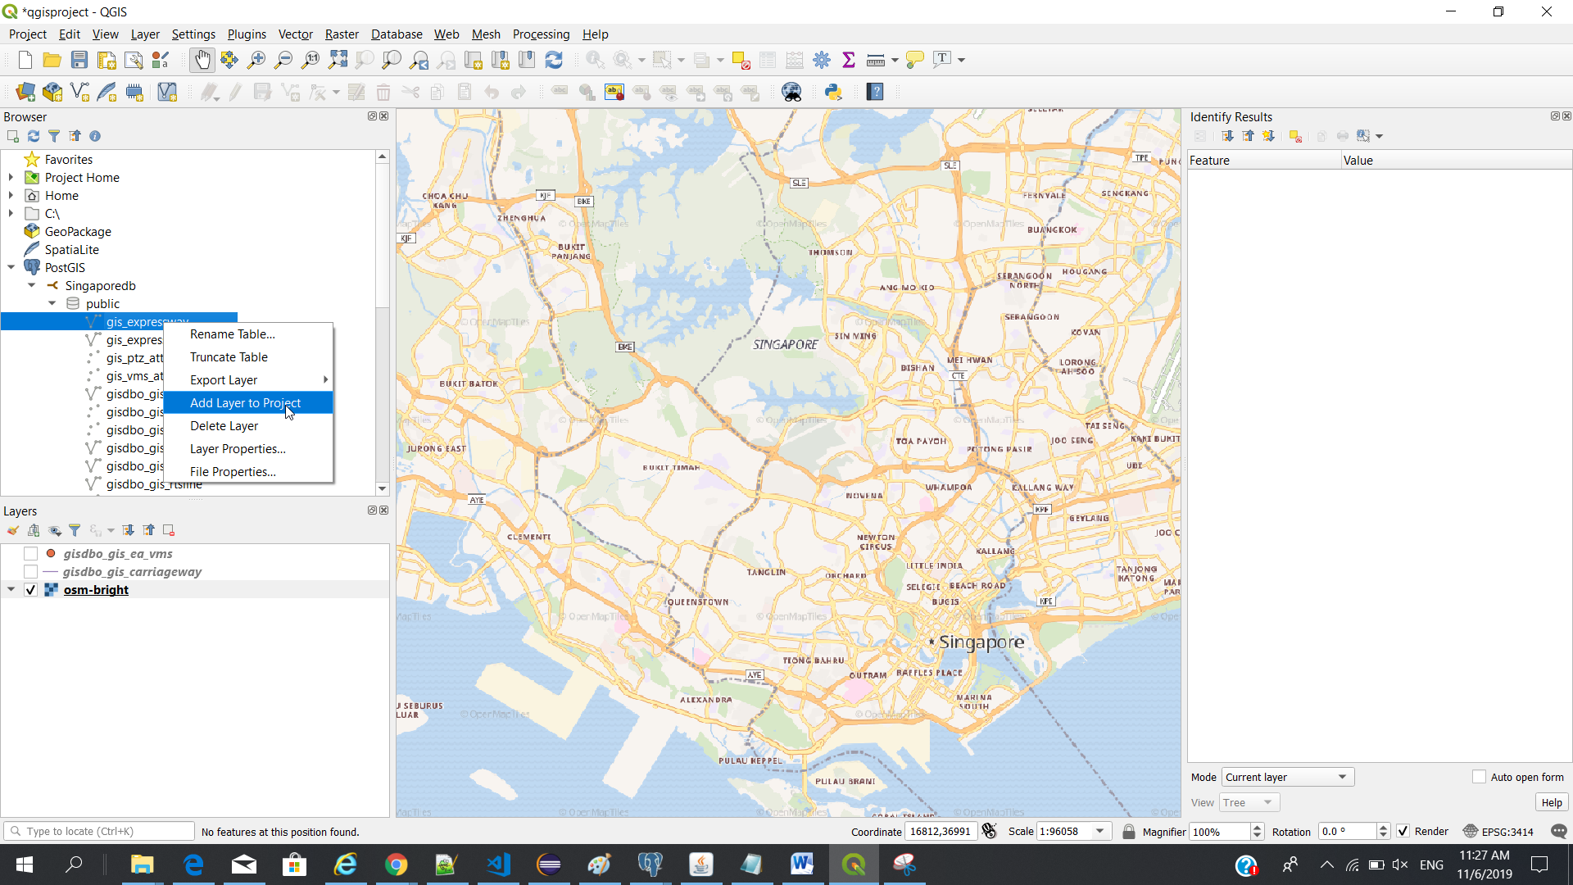

Click “OK”

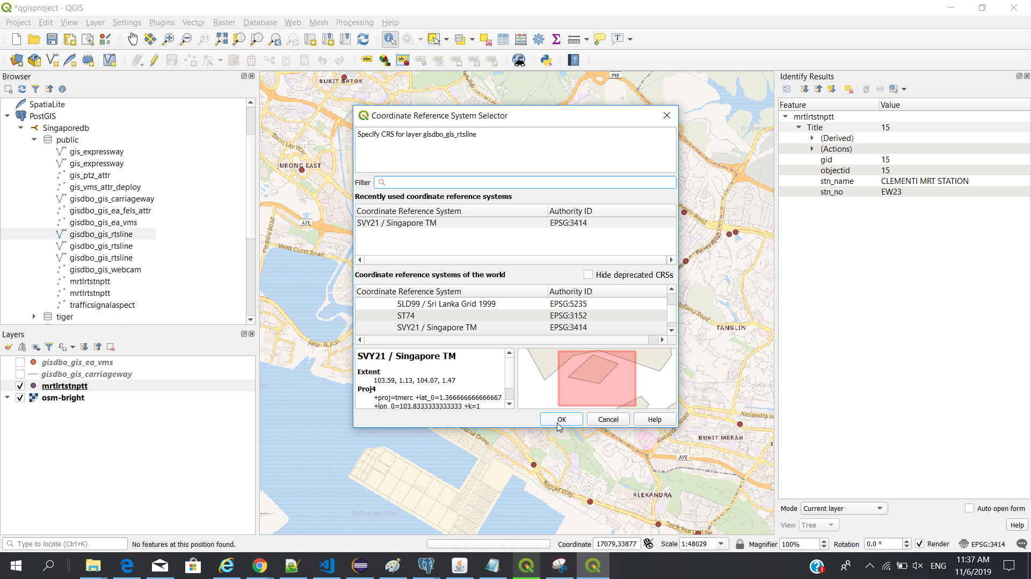

1. MRT layer added also display on the map

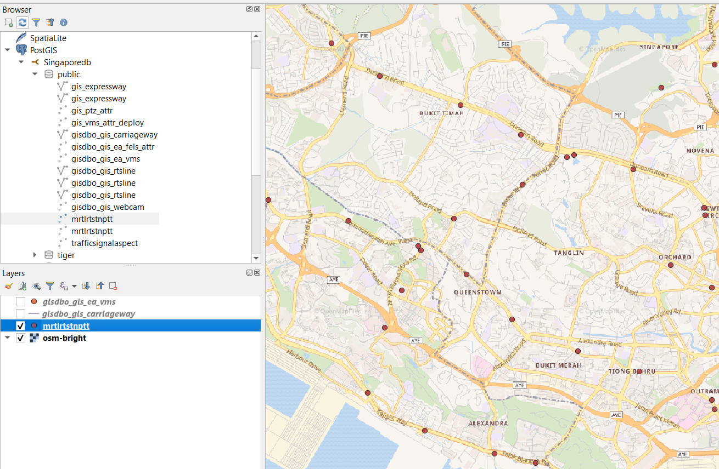

1. To point the location

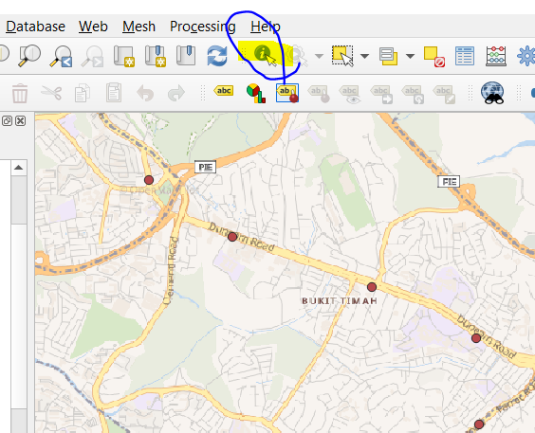

1. To view the mrt location XY value or database column value

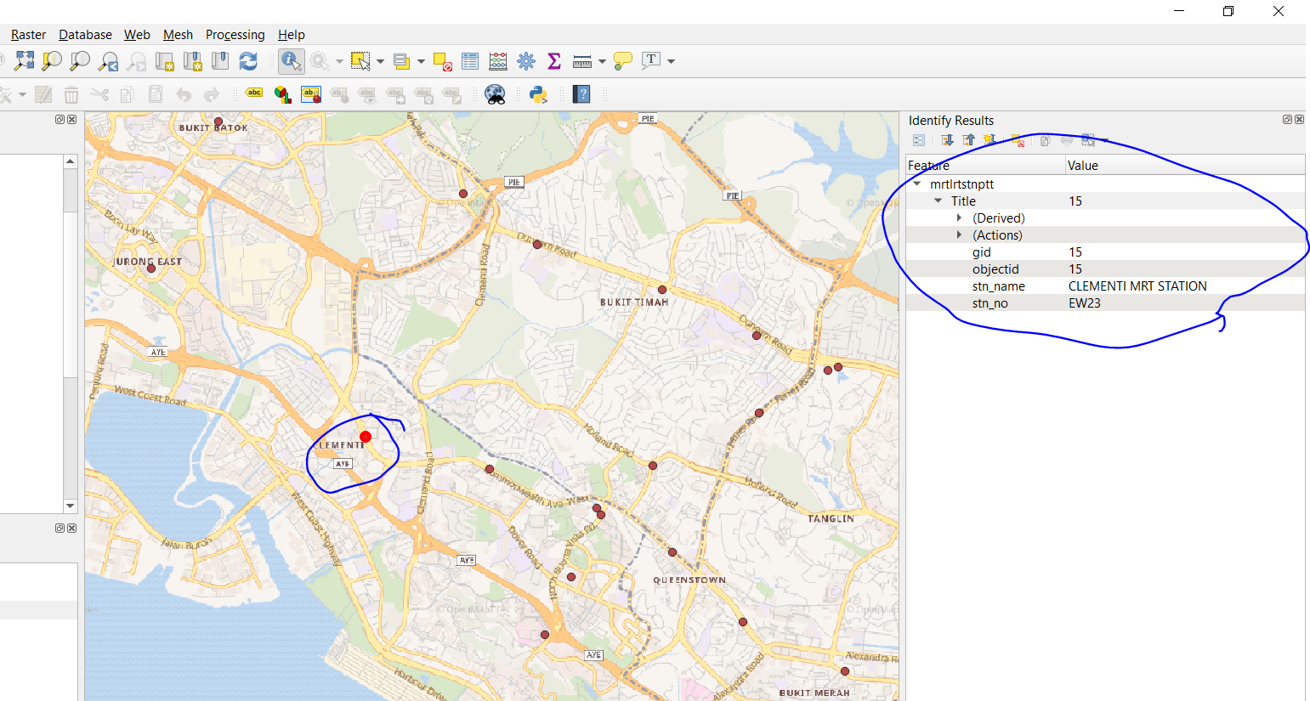

1. To move the mop location using “hand”

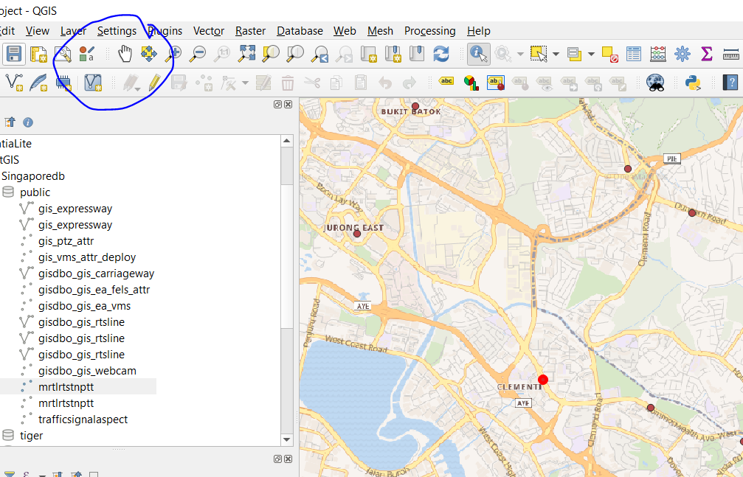

## Brief about all operation:

1. Load Database using PosGIS option from the left
2. Load the basemap layer using basemap URL
3. Load the layer using form the database
4. Vms points on the map
5. VMS location on the table

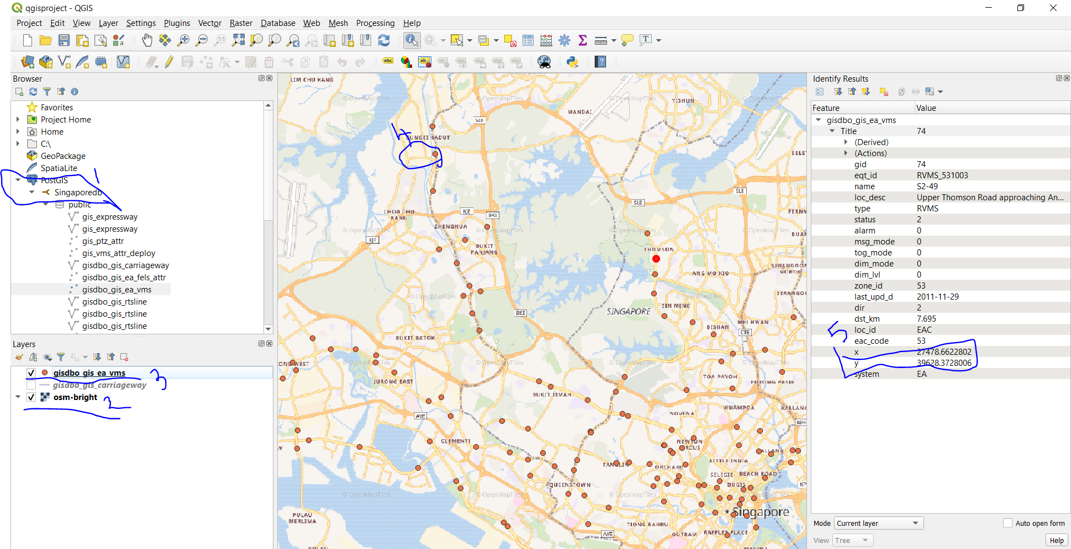

# Transform Coordinates

**Convert xy to longitude and latitude**

<https://epsg.io/transform#s_srs=3414&t_srs=4326&x=33366.0958510&y=32069.8043540>

Notes : if

1. If input coordinates is XY value then choose EPSG 3414
2. If input coordinates is Longitude/Latitude value then choose EPSG 4326
3. format dec – decimal
4. Show position on a map – to view on map

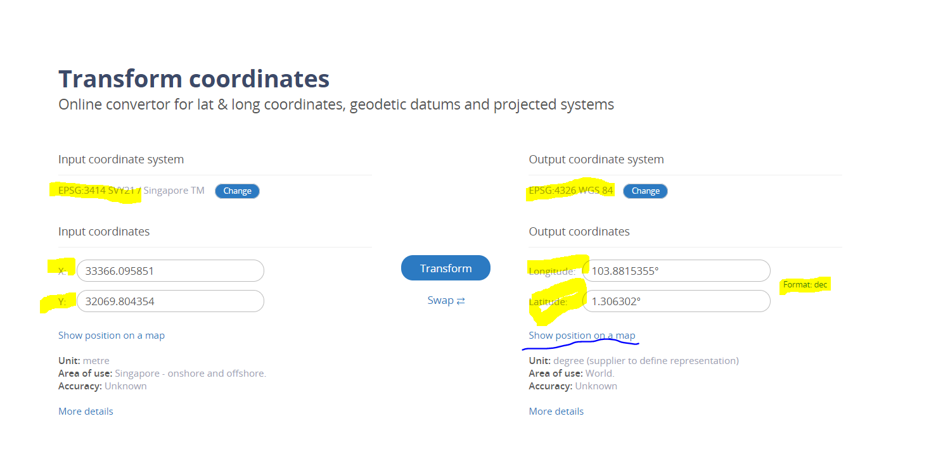

Click - Show position on a map

(+) go into the location

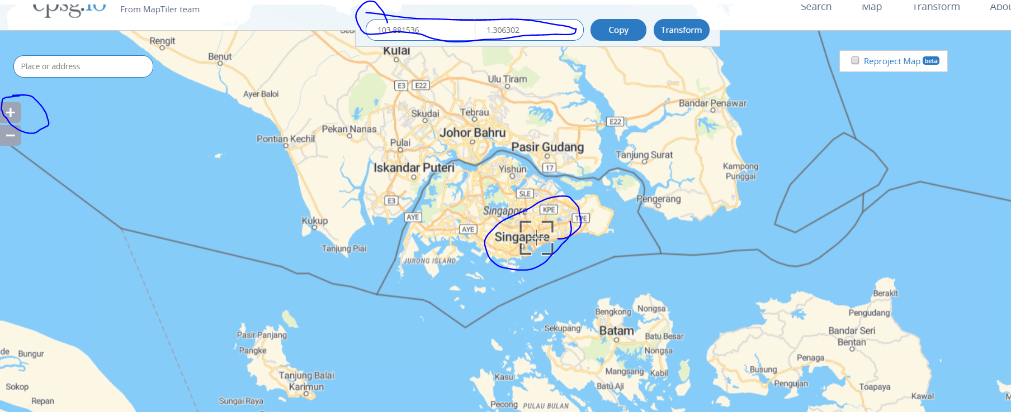

# New Layer configuration with Geo Server and Postgres SQL

New GLIDE data layer added are the latest data.

You can style the glide points using the same steps that you use for VMS layers.

**I. Import data into PostGIS database**

1. Unzip the attached file.
2. Open pgAdmin III.
3. Open PostGIS Shapefile and DBF loader
4. 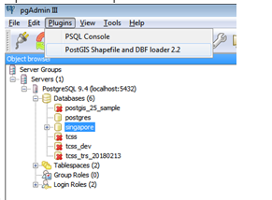
5. Make sure your connection is to Singaporedb.
6. Click Add File button and choose the GIS_GLIDE_SITE shp file. Make sure you are importing to public schema which is the same schema as your existing ITPT2 data.

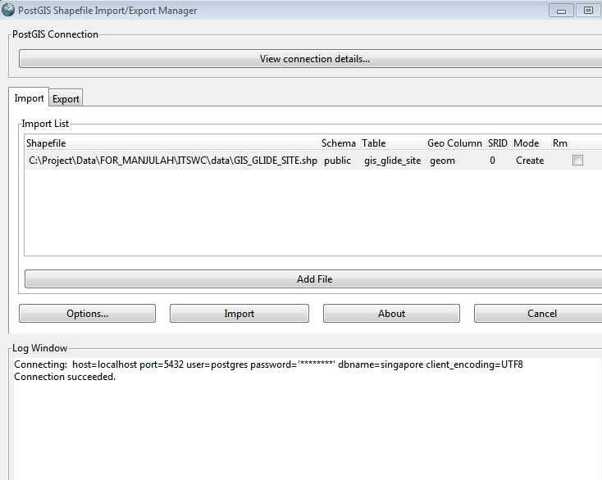

6. Click Import button.

7. gis_glide_site data should be under public schema in your singaporedb database.

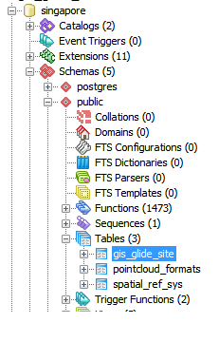

**II. Publish the map service in GeoServer**

1. Go to GeoServer page in browser (<http://localhost:8088/geoserver/web/>) and log in as admin.

2. Click on Layers in left panel and then click on **Add a new layer** in right panel.

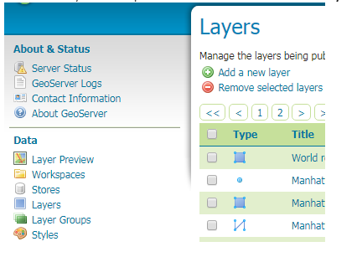

3. Choose your workspace name for Singapore data.

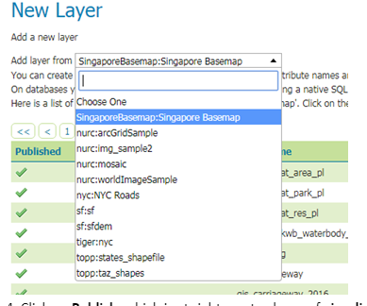

4. Click on **Publish** which is at right most column of **gis_glide_site**row. A new page will be shown.

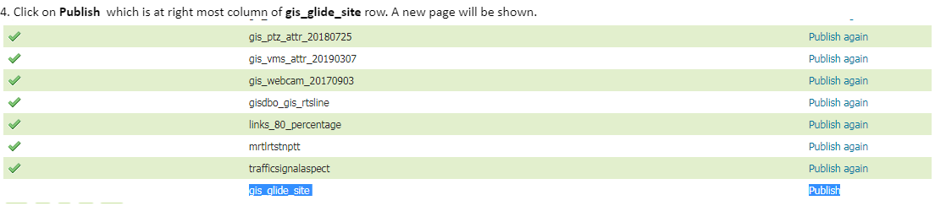

5. Click on **Find** button under **Coordinate Reference System.**A new popup window will be displayed. Click on 3414 to choose SVY21 / Singapore TM. 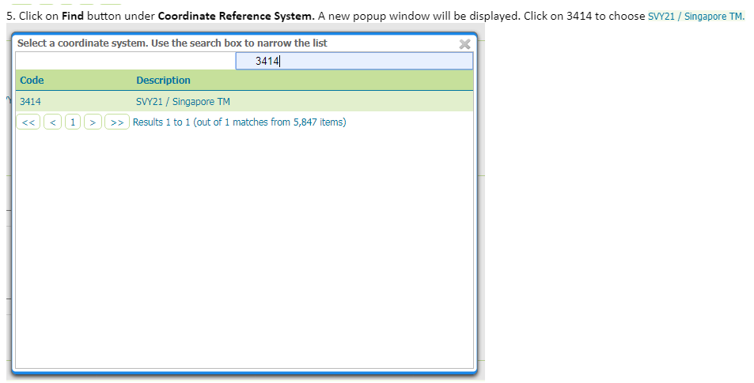

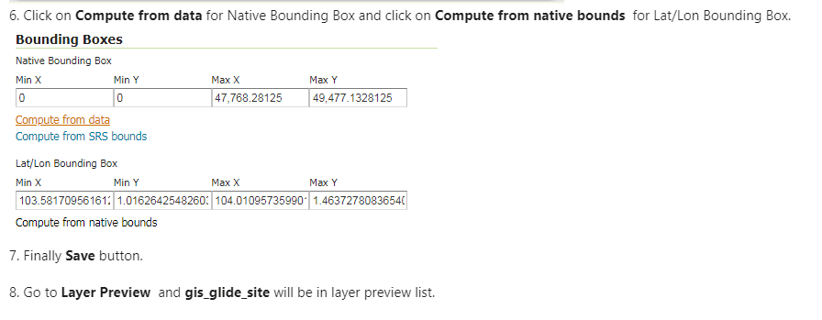

7. Finally **Save**button.

8. Go to **Layer Preview** and **gis_glide_site** will be in layer preview list.

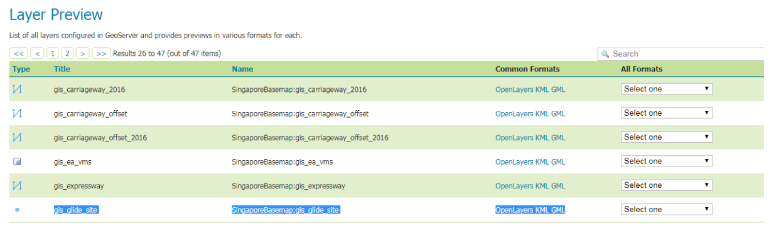

# [ArcGIS API for JavaScript 3.28](https://developers.arcgis.com/javascript/3/)

1. Download ArcGIS arcgis_js_v328_api. Choose the correct version and download
2. Installation html file available inside the zip file. Open and follow the instruction.
3. The ArcGIS API for JavaScript library can be copied in its entirety to your web server directory
4. you will need to edit some files to specify the baseUrl (www.example.com/arcgis_js_api/library/3.28/) for the default Dojo configuration.
5. Copy folder Library/3.28/ and paste it into your application main folder
6. Modify your file init.js/dojo.js

Using HTTP

Note: While not recommended, it is possible to host the ArcGIS API for JavaScript library using http. The dojo.js and init.js files would need modification to update https to http.  
Before: baseUrl:"https://www.example.com/arcgis_js_api/library/3.28/3.28/dojo"  
After: baseUrl:"http://www.example.com/arcgis_js_api/library/3.28/3.28/dojo"

<https://www.example.com/> - local folder location to http://localhost:8080/DemoTrans

Dockers installation

DockerToolbox.exe – Run as administrator mode

Top of Form